**INTERNSHIP REPORT**

**On**

**“ZABBIX MONITORING TOOL”**

**Submitted**

**By**

**M.SATHWIK REDDY**

**UNDER THE GUIDANCE OF:**

**Mr. Arunanjan Pattanayak**

**UNIT IT-HEAD INFORMATION SYSTEM DEPARTMENT**

**ITC LTD-PSPD UNIT, BHADRACHALAM.**



**IS Department**

This is to certify that the project report entitled “**ZABBIX MONITORING TOOL**”, is a Bonafide record of work done by Mr.“M.SATHWIK REDDY” under our supervision at the “ITC PSPD ltd”.

Unit IT Head

(Mr. Arunanjan Pattanayak)

Company details:

ITC Limited

PAPERBOARDS & SPECIALITY PAPERS DIVISION

SARAPAKA – 507128

Bhadradri,kothagudem Dist, Telangana

**ACKNOWLEDGEMENT**

I thank the people concerned with the management at ITC-PSPD BCM for providing me with this opportunity to undergo internship training at the IS department.

I would now bound to thank , Mr.Sourav Mukherjee(HR DEPEATMENT), Mr. Arunanjan Pattanayak (UNIT IT HEAD), Mr.V.Sairam (CCTV ADMIN) for granting me permission and explore my internship in such a great platform.

Secondly, I thank all the staff of ITC Ltd-PSPD., who helped me in getting the programming done in IS department, ITC Ltd- PSPD. I’m very grateful to all who have extended their kind co-operation in Information System Department.

I thank each and every one who helped me in completing the internship.

**CONTENTS**

**INTRODUCTION**

Internship was my first step in practical life, which made me link up with the theoretical knowledge gained. This internship has given me with a great valuable experience that would help me once I enter the professional career. Internship offered to me was 30 days training and operations.

My main motto of getting into a prestigious company as an Internee is to get learn about how people deal in their workplace. It taught me how to get along with the people that I have to work with every day, building confidence and improving my skills and specially my way of thinking has drastically changed, and my approach to problem solving has taken a new way out of it.

This work is the collection of my observation and experience during the internship period. This experience has taught me responsibility, teamwork and how to tackle problems. Even though the nature of work was quite basic as an internee, nevertheless I got to see what practical life is.

I also have gained knowledge about how information flow one department to another with the help of internet. Besides this, I developed the skills to communicate with people approaching with queries.

The specific objectives of the study are:

* To implement the theoretical knowledge in the real-world environment.
* To build up confidence, interpersonal and communication skills.
* To understand how resource sharing is done in a real working environment.
* To gain knowledge about networking and its various technical terms.
* To know how documentation is done, records are created and maintained and security consideration is implemented.
* To increase a sense of responsibility and acquire good work habit.

**OVERVIEW OF ORGANIZATION**

ITC is one of India’s foremost multi-business enterprises with a market capitalization of US$45 billion and a turnover of US$ 8 billion. ITC is rated among the world’s best big companies, Asia’s ‘Fab 50’ and the world’s Most Reputable Companies by Forbes magazine and Hay Group. ITC also features as one of world’s largest sustainable value creator in the consumer goods industry in a study by the Boston Consulting Group. ITC has been listed among India’s ’10 Most Valuable (Company) Brands’, according to a study conducted by Brand Finance and published by the Economic Times.

ITC also ranks among Asia’s 50 best performing companies compiled by Business week. ITC is India’s leading Fast Moving Consumer Goods company, the clear market leader in the Indian Paperboard and Packaging industry a globally acknowledged pioneer in farmer empowerment through its wide-reaching Agri Business and runs the greenest luxury hotel chain in the world. ITC info Tech, a wholly-owned subsidiary, is one of India’s fast-growing IT companies in the mid-tier segment. This portfolio of rapidly growing business considerably enhances ITC’s capacity to generate growing value for the Indian economy. ITC PSPD, Bhadrachalam consists of the following:

* 7 machines with production capacity of 412,000 TPA of Paperboard and 140,000 TPA of paper
* Specialty boards for playing cards and scratch cards, C2S Art Boards and Ivory Boards
* Commissioned India’s first Elemental Chlorine Free bleaching line, later followed by another line incorporating Light ECF process with a combined capacity of 260,000 TPA
* ISO 9001, ISO 14001 and OHSAS 18001 accredited.
* Forest Stewardship Council-chain of Custody certified.
* BRC Global Standard certified for food grade boards.



**Zabbix** is an open-source monitoring software tool that is designed to monitor and track the performance and availability of networks, servers, applications, and other IT resources. It provides real-time monitoring, alerting, and visualization of various metrics, allowing administrators to proactively detect and resolve issues before they affect the performance or availability of IT services.

Zabbix is a robust and flexible monitoring solution that enables organizations to monitor the performance and availability of their IT infrastructure in real-time. Whether it's servers, networks, applications, or cloud resources, Zabbix provides comprehensive monitoring capabilities to ensure that your systems are running smoothly and efficiently.

**Key Features:**

1.**Real-Time Monitoring:** Zabbix offers real-time monitoring of various metrics such as CPU usage, memory utilization, network traffic, disk space, and more.

2.**Alerting and Notification:** It allows users to define flexible alerting rules based on predefined thresholds, ensuring timely notifications via email, SMS, or other channels when issues occur.

3.**Visualization and Reporting:** Zabbix provides customizable dashboards and

reports, allowing users to visualize data trends, analyze historical performance, and generate insightful reports.

4**.Scalability:** From small environments to large-scale deployments, Zabbix scales effortlessly to meet the monitoring needs of organizations of all sizes.

5.**Automation:** Zabbix supports automation through its robust API, enabling integration with other systems and automation tools for streamlined operations.

6.**Flexible Architecture:** With its distributed architecture, Zabbix can be deployed in various configurations to accommodate complex IT infrastructures and ensure high availability.

**Components:**

1.**Zabbix Server:** The core component responsible for data collection, processing, and storage. It also manages the configuration and processing of monitoring data.

2.**Zabbix Agents:** Lightweight daemons installed on monitored hosts to collect and send data to the Zabbix server.

3.**Web Interface:** A user-friendly web interface for configuration, monitoring, and administration tasks.

4.**Database:** Zabbix utilizes a relational database (MySQL, PostgreSQL, SQLite, or Oracle) to store configuration data, historical metrics, and monitoring statistics.

**Getting Started:**

To start using Zabbix, you'll typically should have :

1.**Install Zabbix Server:** Set up the Zabbix server and configure the necessary components.

2.**Deploy Agents:** Install Zabbix agents on the hosts you want to monitor.

3.**Configure Monitoring:** Define hosts, configure monitoring parameters, and set up alerting rules as per your requirements.

4.**Explore Data:** Use the web interface to visualize monitored data, create dashboards, and generate reports.

5.**Monitor and Maintain:** Continuously monitor your infrastructure, adjust configurations as needed, and ensure optimal performance and availability.

**Zabbix empowers organizations to proactively monitor their IT infrastructure, identify potential issues, and take corrective actions to maintain a stable and efficient environment.**

#### Architecture

Zabbix consists of several major software components. Their responsibilities are outlined below.

##### **Server**

[Zabbix server](https://www.zabbix.com/documentation/current/en/manual/concepts/server) is the central component to which agents report availability and integrity information and statistics. The server is the central repository in which all configuration, statistical and operational data are stored.

##### **Database storage**

All configuration information as well as the data gathered by Zabbix is stored in a database.

##### **Web interface**

For an easy access to Zabbix from anywhere and from any platform, the web-based interface is provided. The interface is part of Zabbix server, and usually (but not necessarily) runs on the same physical machine as the one running the server.

##### **Proxy**

[Zabbix proxy](https://www.zabbix.com/documentation/current/en/manual/concepts/proxy) can collect performance and availability data on behalf of Zabbix server. A proxy is an optional part of Zabbix deployment; however, it may be very beneficial to distribute the load of a single Zabbix server.

##### **Agent**

Zabbix agents are deployed on monitoring targets to actively monitor local resources and applications and report the gathered data to Zabbix server.

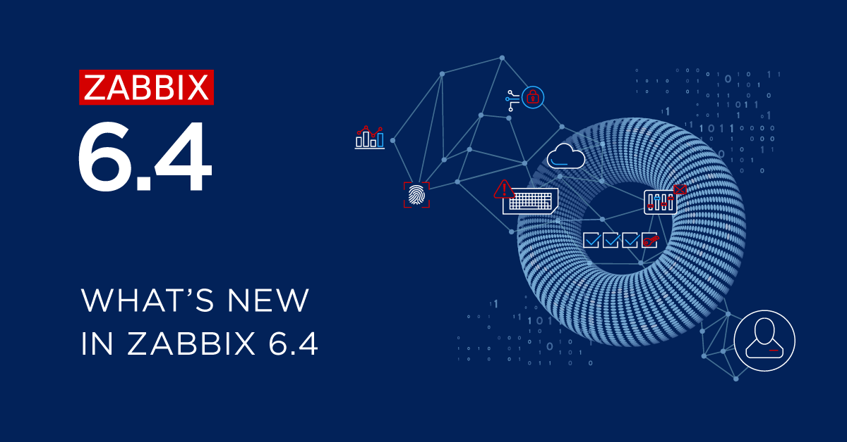

[**What's new in Zabbix 6.4.14**](https://www.zabbix.com/documentation/current/en/manual/introduction/whatsnew6414#whats-new-in-zabbix-6.4.14)

[**Databases**](https://www.zabbix.com/documentation/current/en/manual/introduction/whatsnew6414#databases)

[**MariaDB 11.3 support**](https://www.zabbix.com/documentation/current/en/manual/introduction/whatsnew6414#mariadb-11.3-support)

The maximum [supported version](https://www.zabbix.com/documentation/current/en/manual/installation/requirements#third-party-external-surrounding-software) for MariaDB is now 11.3.X.

[**Templates**](https://www.zabbix.com/documentation/current/en/manual/introduction/whatsnew6414#templates)

[**New templates**](https://www.zabbix.com/documentation/current/en/manual/introduction/whatsnew6414#new-templates)

* [Oracle Cloud by HTTP](https://git.zabbix.com/projects/ZBX/repos/zabbix/browse/templates/cloud/oracle_cloud?at=refs%2Fheads%2Frelease%2F6.4), a master template that discovers various Oracle Cloud Infrastructure (OCI) services and resources.

[**Updated templates**](https://www.zabbix.com/documentation/current/en/manual/introduction/whatsnew6414#updated-templates)

* [FortiGate by SNMP](https://git.zabbix.com/projects/ZBX/repos/zabbix/browse/templates/net/fortinet/fortigate_snmp?at=refs%2Fheads%2Frelease%2F6.4) template has been supplemented with metrics regarding VPN, high availability (HA), wireless termination points (WTPs), SD-WAN health checks, and HW sensors.
* [MySQL by ODBC](https://git.zabbix.com/projects/ZBX/repos/zabbix/browse/templates/db/mysql_odbc/README.md?at=refs%2Fheads%2Frelease%2F6.4) template has been supplemented with the items "MySQL: Get database" and "MySQL: Get replication". The LLD rules "Database discovery" and "Replication discovery" have been changed to the "Dependent item" type.
* [Oracle by ODBC](https://git.zabbix.com/projects/ZBX/repos/zabbix/browse/templates/db/oracle_odbc/README.md?at=refs%2Fheads%2Frelease%2F6.4) template has been supplemented with the items "Oracle: Get archive log", "Oracle: Get ASM disk groups", "Oracle: Get database", "Oracle: Get PDB", and "Oracle: Get tablespace". The LLD rules "Archive log discovery", "ASM disk groups discovery", "Database discovery", "PDB discovery", and "Tablespace discovery" have been changed to the "Dependent item" type.
* The VMware Hypervisor template within the [VMware](https://git.zabbix.com/projects/ZBX/repos/zabbix/browse/templates/app/vmware?at=refs%2Fheads%2Frelease%2F6.4) and [VMware FQDN](https://git.zabbix.com/projects/ZBX/repos/zabbix/browse/templates/app/vmware_fqdn?at=release%2F6.4) template sets has been supplemented with a new LLD rule, "Sensor discovery".

#### Definitions

[**Host**](https://www.zabbix.com/documentation/current/en/manual/config/hosts)

Any physical or virtual device, application, service, or any other logically-related collection of monitored parameters.

[**Host group**](https://www.zabbix.com/documentation/current/en/manual/config/hosts)

A logical grouping of hosts. Host groups are used when assigning access rights to hosts for different user groups.

[**Item**](https://www.zabbix.com/documentation/current/en/manual/config/items)

A particular piece of data that you want to receive from a host, a metric of data.

[**Value preprocessing**](https://www.zabbix.com/documentation/current/en/manual/config/items/item#item-value-preprocessing)

A transformation of received metric value*before saving it to the database.*

[**Trigger**](https://www.zabbix.com/documentation/current/en/manual/config/triggers)

A logical expression that defines a problem threshold and is used to "evaluate" data received in items.

When received data are above the threshold, triggers go from 'Ok' into a 'Problem' state. When received data are below the threshold, triggers stay in/return to an 'Ok' state.

[**Template**](https://www.zabbix.com/documentation/current/en/manual/config/templates)

A set of entities (items, triggers, graphs, low-level discovery rules, web scenarios) ready to be applied to one or several hosts.

The job of templates is to speed up the deployment of monitoring tasks on a host; also to make it easier to apply mass changes to monitoring tasks. Templates are linked directly to individual hosts.

[**Template group**](https://www.zabbix.com/documentation/current/en/manual/config/templates)

A logical grouping of templates. Template groups are used when assigning access rights to templates for different user groups.

[**Event**](https://www.zabbix.com/documentation/current/en/manual/config/events)

A single occurrence of something that deserves attention such as a trigger changing state or a discovery/agent auto registration taking place.

[**Event tag**](https://www.zabbix.com/documentation/current/en/manual/config/event_correlation/trigger/event_tags)

A pre-defined marker for the event. It may be used in event correlation, permission granulation, etc.

[**Event correlation**](https://www.zabbix.com/documentation/current/en/manual/config/event_correlation)

A method of correlating problems to their resolution flexibly and precisely.

For example, you may define that a problem reported by one trigger may be resolved by another trigger, which may even use a different data collection method.

[**Problem**](https://www.zabbix.com/documentation/current/en/manual/web_interface/frontend_sections/monitoring/problems)

A trigger that is in "Problem" state.

[**Problem update**](https://www.zabbix.com/documentation/current/en/manual/acknowledgment#updating-problems)

Problem management options provided by Zabbix, such as adding comment, acknowledging, changing severity or closing manually.

[**Action**](https://www.zabbix.com/documentation/current/en/manual/config/notifications/action)

A predefined means of reacting to an event.

An action consists of operations (e.g. sending a notification) and conditions (when the operation is carried out)

[**Escalation**](https://www.zabbix.com/documentation/current/en/manual/config/notifications/action/escalations)

A custom scenario for executing operations within an action; a sequence of sending notifications/executing remote commands.

[**Media**](https://www.zabbix.com/documentation/current/en/manual/config/notifications/media)

A means of delivering notifications; delivery channel.

[**Notification**](https://www.zabbix.com/documentation/current/en/manual/config/notifications/action/operation/message)

A message about some event sent to a user via the chosen media channel.

[**Remote command**](https://www.zabbix.com/documentation/current/en/manual/config/notifications/action/operation/remote_command)

A pre-defined command that is automatically executed on a monitored host upon some condition.

[**Web scenario**](https://www.zabbix.com/documentation/current/en/manual/web_monitoring)

One or several HTTP requests to check the availability of a web site.

[**Frontend**](https://www.zabbix.com/documentation/current/en/manual/introduction/overview#architecture)

The web interface provided with Zabbix.

[**Dashboard**](https://www.zabbix.com/documentation/current/en/manual/web_interface/frontend_sections/dashboards)

Customizable section of the web interface displaying summaries and visualizations*of important information in visual units called widgets.*

[**Widget**](https://www.zabbix.com/documentation/current/en/manual/web_interface/frontend_sections/dashboards/widgets)

Visual unit displaying information of a certain kind and source (a summary, a map, a graph, the clock, etc.), used in the dashboard.

[**Zabbix API**](https://www.zabbix.com/documentation/current/en/manual/api)

Zabbix API allows you to use the JSON RPC protocol to create, update and fetch Zabbix objects (like hosts, items, graphs and others) or perform any other custom tasks.

[**Zabbix server**](https://www.zabbix.com/documentation/current/en/manual/concepts/server)

A central process of Zabbix software that performs monitoring, interacts with Zabbix proxies and agents, calculates triggers, sends notifications; a central repository of data.

[**Zabbix proxy**](https://www.zabbix.com/documentation/current/en/manual/concepts/proxy)

A process that may collect data on behalf of Zabbix server, taking some processing load from the server.

[**Zabbix agent**](https://www.zabbix.com/documentation/current/en/manual/concepts/agent)

A process deployed on monitoring targets to actively monitor local resources and applications.

[**Zabbix agent 2**](https://www.zabbix.com/documentation/current/en/manual/concepts/agent2)

A new generation of Zabbix agent to actively monitor local resources and applications, allowing to use custom plugins for monitoring.

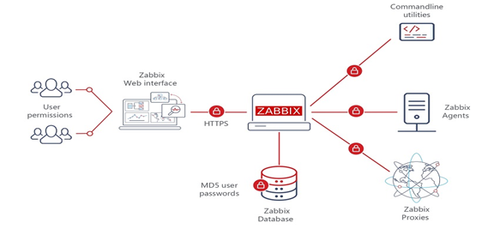

**Hyper-V Manager**

**Hyper-V Manager** is a Windows utility that allows users to create, manage, and run virtual machines (VMs) on a Windows server or client operating system. It's part of the Hyper-V role, which can be installed on supported versions of Windows, such as Windows Server and Windows 10 Pro or Enterprise.

**Key Features of Hyper-V Manager**

**Virtual Machine Management:** Hyper-V Manager provides a centralized interface for creating, configuring, and managing virtual machines. Users can create new VMs, modify their settings (such as CPU, memory, storage), start, stop, pause, and delete VMs as needed.

**Virtual Networking:** Hyper-V Manager allows users to configure virtual networks for communication between virtual machines and the external network. It supports various network configurations, including external, internal, and private networks, enabling flexible connectivity options.

**Resource Monitoring:** Users can monitor the resource usage of virtual machines, such as CPU, memory, disk, and network utilization, through Hyper-V Manager. This helps in optimizing resource allocation and identifying potential performance bottlenecks.

**Snapshot Management**: Hyper-V Manager enables users to take snapshots of virtual machines at specific points in time. Snapshots capture the VM's state, including memory, disk, and configuration settings, allowing users to revert to previous states if needed or create checkpoints for testing and troubleshooting purposes.

**Integration Services:** Hyper-V Manager provides integration services that enhance the performance and functionality of virtual machines running on Hyper-V hosts. These services include time synchronization, guest OS shutdown, heartbeat, and backup integration, improving the overall VM experience.

**Virtual Machine Migration:** Hyper-V Manager supports live migration and quick migration of virtual machines between Hyper-V hosts, enabling workload mobility and minimizing downtime during maintenance or hardware upgrades.

**Remote Management:** Hyper-V Manager can manage Hyper-V hosts remotely, allowing administrators to control virtual machine operations and configurations from a centralized console, even across a network.

**Configuring Hyper-V**

Configuring Hyper-V on a Windows Server involves several steps to ensure that the virtualization platform is set up correctly and ready to create and manage virtual machines. Below are the steps to configure Hyper-V on a Windows Server:

**1. Install the Hyper-V Role:**

**Step 1:** **Open Server Manager:**

• Press the Windows key, type "Server Manager," and press Enter to open it.

**Step 2:** **Add Roles and Features:**

• In Server Manager, click on "Add roles and features" from the Dashboard or the Manage menu on the top right.

**Step 3:** **Role-Based or Feature-Based Installation:**

• Choose "Role-based or feature-based installation" and click Next.

**Step 4:** **Select a Server:**

• Ensure that your local server is selected and click Next.

**Step 5:** **Select Server Roles:**

• Scroll down, locate "Hyper-V," check the box, and click Next.

**Step 6:** **Add Features:**

• Review the features that will be installed with Hyper-V and click Next.

**Step 7:** **Confirmation:**

• Confirm the installation selections and click Install.

**Step 8: Installation Progress:**

• Wait for the installation to complete.

**Step 9: Restart:**

• After the installation is complete, you may need to restart the server. Click Close and then Yes to restart the server.

**2. Configure Hyper-V Settings:**

**Step 1: Open Hyper-V Manager:**

• After the server restarts, open Hyper-V Manager. You can find it in the Start menu or by searching for "Hyper-V Manager."

**Step 2: Configure Hyper-V Settings:**

• In Hyper-V Manager, click on your Hyper-V server in the left pane.

• Under the Actions pane on the right, click on "Hyper-V Settings."

• Configure settings such as default locations for virtual machine storage, virtual hard disk management, live migrations, and processor compatibility.

**3. Create Virtual Networks:**

Step 1: Open Hyper-V Manager:

• If you haven't already done so, open Hyper-V Manager.

**Step 2: Create Virtual Switches:**

• In Hyper-V Manager, click on your Hyper-V server in the left pane.

• Under the Actions pane on the right, click on "Virtual Switch Manager."

• Create virtual switches as needed for communication between virtual machines and the external network. Choose the appropriate type of virtual switch (External, Internal, or Private) and configure settings accordingly.

**4. Create Virtual Machines:**

Step 1: Open Hyper-V Manager:

• If you haven't already done so, open Hyper-V Manager.

**Step 2: Create Virtual Machine:**

• In Hyper-V Manager, click on your Hyper-V server in the left pane.

• Under the Actions pane on the right, click on "New" and then "Virtual Machine."

• Follow the wizard to create a new virtual machine, specifying settings such as name, generation, memory, virtual hard disk, and network connectivity.

**5. Manage Virtual Machines:**

**Step 1: Open Hyper-V Manager:**

• If you haven't already done so, open Hyper-V Manager.

**Step 2: Manage Virtual Machines:**

• In Hyper-V Manager, you can start, stop, pause, resume, and perform other management tasks on virtual machines. Right-click on a virtual machine in the left pane to access these options.

By following these steps,

**you can configure Hyper-V on your Windows Server and start creating and managing virtual machines for your infrastructure.** Adjust the settings and configurations as needed based on your specific requirements.

**Installing Hyper-V Manager**

Installing Hyper-V Manager involves enabling the Hyper-V role on a Windows server or client operating system. Below are the steps to install Hyper-V Manager on Windows Server and Windows 10:

Installing Hyper-V Manager on Windows Server:

**Step 1: Open Server Manager:**

Press the Windows key, type "Server Manager," and press Enter to open it.

**Step 2: Add Roles and Features:**

In Server Manager, click on "Add roles and features" from the Dashboard or the Manage menu on the top right.

**Step 3: Role-Based or Feature-Based Installation:**

Choose "Role-based or feature-based installation" and click Next.

**Step 4: Select a Server:**

Ensure that your local server is selected and click Next.

**Step 5: Select Server Roles**

Scroll down, locate "Hyper-V," check the box, and click Next.

**Step 6: Add Features:**

Review the features that will be installed with Hyper-V and click Next.

**Step 7: Confirmation:**

Confirm the installation selections and click Install.

Step 8: Installation Progress:

Wait for the installation to complete.

**Step 9: Restart:**

After the installation is complete, you may need to restart the server. Click Close and then Yes to restart the server.

**Step 10: Access Hyper-V Manager:**

After the server restarts, you can access Hyper-V Manager from the Start menu or by searching for "Hyper-V Manager."

**Installing Hyper-V Manager on Windows 10:**

**Step 1: Open Control Panel:**

Press the Windows key, type "Control Panel," and press Enter to open it.

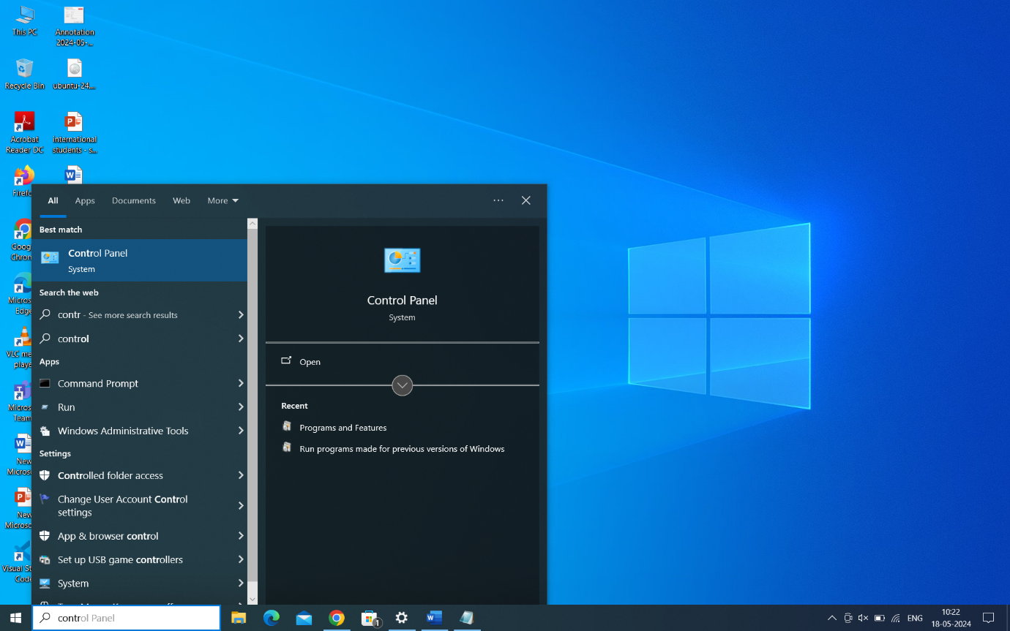

**Step 2: Programs and Features:**

In Control Panel, click on "Programs" and then click on "Turn Windows features on or off."

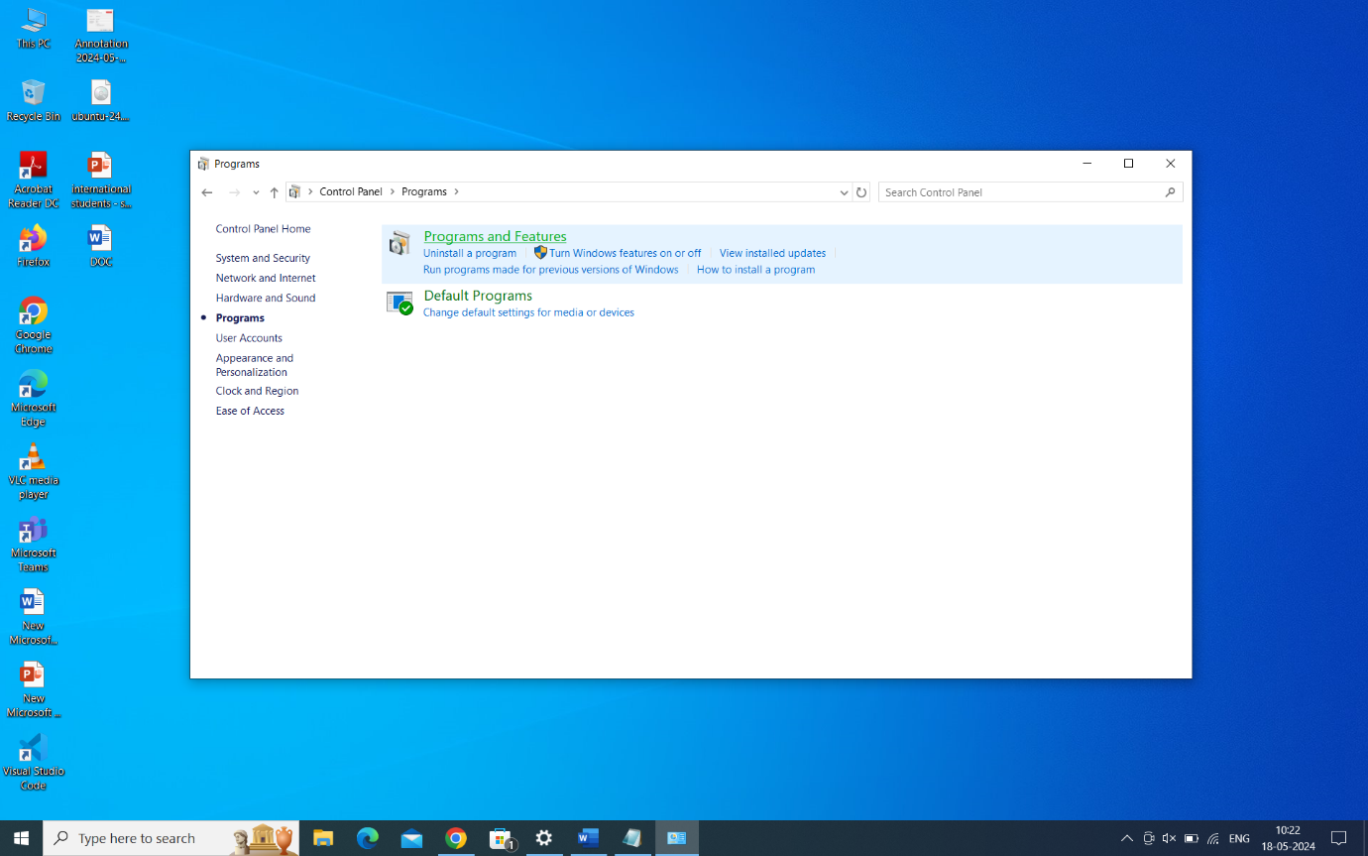

**Step 3: Enable Hyper-V:**

Check the box next to "Hyper-V" and its sub-components (Hyper-V Platform and Hyper-V Management Tools) and click OK.

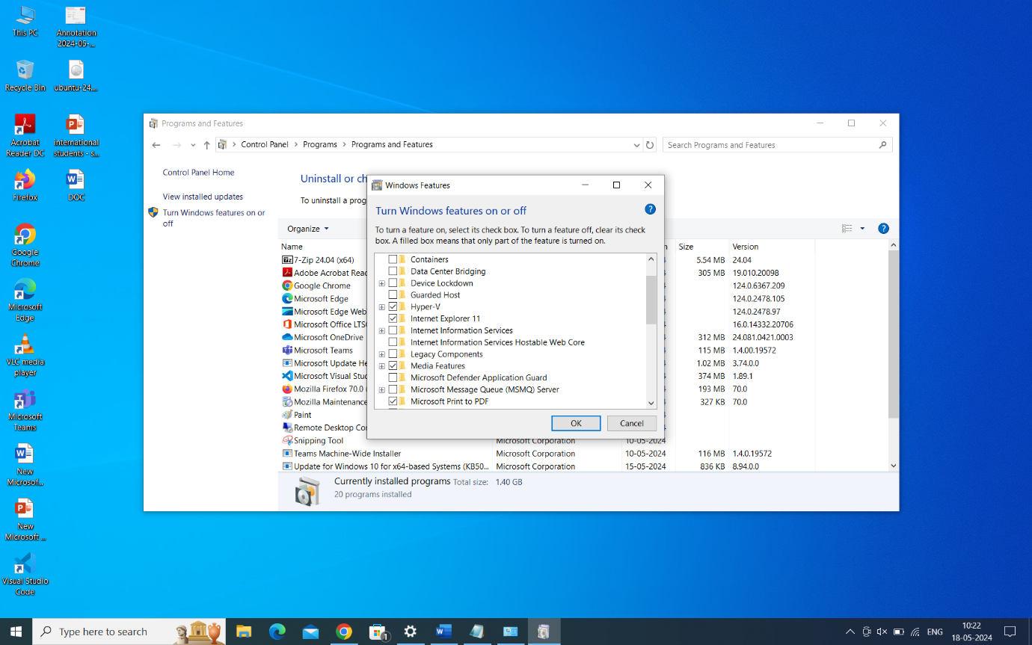

**Step 4: Installation Progress:**

Windows will install the Hyper-V feature. This may take some time.

**Step 5: Restart:**

After the installation is complete, you may need to restart your computer. Click Restart now or Restart later as per your preference.

**Step 6: Access Hyper-V Manager:**

After the computer restarts, you can access Hyper-V Manager from the Start menu or by searching for "Hyper-V Manager."

You've successfully installed Hyper-V Manager on your Windows Server or Windows 10 system.

You can now use Hyper-V Manager to create, configure, and manage virtual machines on your system.

**Installing Ubuntu 24.04**

**Step 1: Download Ubuntu 24.04 ISO:**

Visit the official Ubuntu website (https://ubuntu.com/) and download the ISO image for Ubuntu 24.04.

### **Step 2: Create boot-able USB installer**

We usually burn the Ubuntu iso image into a USB stick, then boot PC with it to get into a live Ubuntu system, and finally start the wizard to install the system to hard disk.

Firstly, a USB stick with 4 GB+ memory is required, download ISO image from [releases.ubuntu.com](https://releases.ubuntu.com/22.04/), and follow this guide to burn it:

[Create boot-able USB installer for Ubuntu 22.04](https://ubuntuhandbook.org/index.php/2022/04/usb-installer-ubuntu-22-04/)

### **Step 3: Boot your PC with the USB**

Next, plug the USB stick into the target PC, start or restart and press F2/F10 (or other keys depends on your machine) to get into BIOS/UEFI. Select boot the USB, and you should see the following screen:

[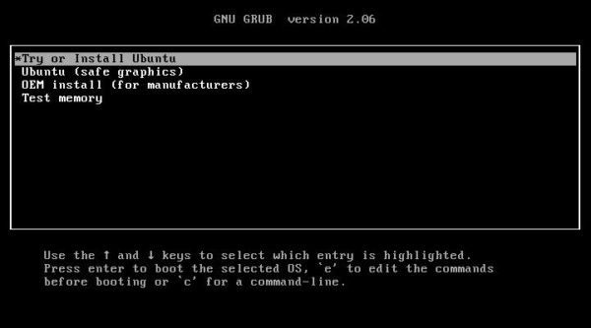](https://ubuntuhandbook.org/wp-content/uploads/2022/04/jammy-grub.jpg)

live-USB boot menu

Finally, select boot the first menu entry, or the second “safe graphics” if the first entry does not work for your machine.

### **Step 4: Start install wizard, choose language & keyboard layout**

It will automatically launch the install wizard after successfully boot into the live system.

In the first page, choose the language for this wizard and live system. Then:

* click “**Try Ubuntu**” to try the live system. There’s a shortcut icon to launch installer again if you decide to install the system on your disk.
* or click “**Install Ubuntu**” to get to next page.

[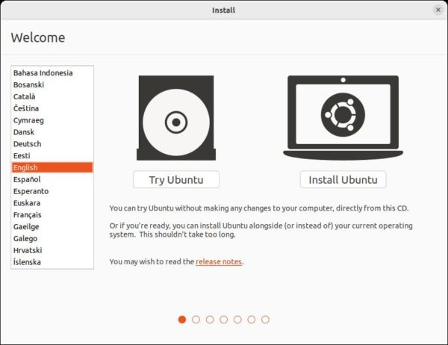](https://ubuntuhandbook.org/wp-content/uploads/2022/04/wizard-start.jpg)

In the next keyboard layout page, it should automatically select the correct keyboard layout. You may press any key on keyboard and see the screen output to verify. Use “Detect Keyboard Layout” or select layout manually if the default is not correct.

[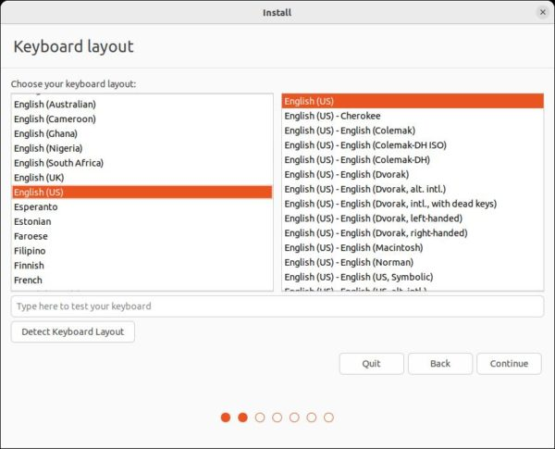](https://ubuntuhandbook.org/wp-content/uploads/2022/04/install-selectkeyboard.jpg)

Next, it will prompt to choose between “Normal Installation” and “Minimal Installation”. We usually choose the former one, unless you just need a web browser along with core system libraries.

For updates and third-party software under “Other options”, check the boxes as you prefer if you has internet connection. They are also available to install after system installation.

[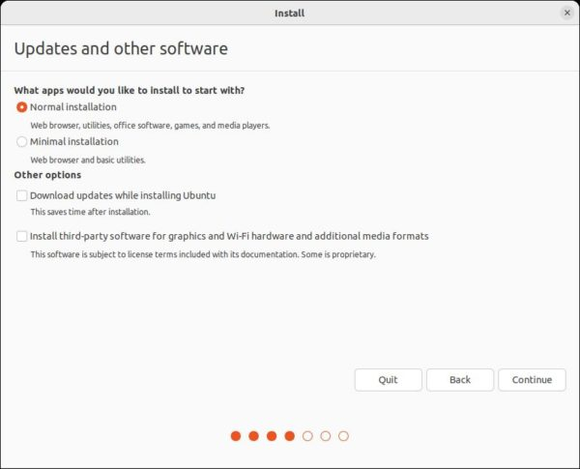](https://ubuntuhandbook.org/wp-content/uploads/2022/04/jammy-wizard-install.jpg)

### **Step 5: Choose disk or assign partition manually**

In the next page, it will ask where to install the Ubuntu system. There are usually following options:

* **Erase disk and install Ubuntu** – use the whole hard disk for Ubuntu. You’ll lost all the data in your disk. There’s also “Advanced features” allows to encrypt the system.
* **Install Ubuntu beside Windows** – If you’ve a Windows system in the disk, there’ll be the option to use all the left space for Ubuntu installation. So you’ll have Ubuntu and Windows dual-boot.
* **Install/Reinstall Ubuntu on top of …** – Clear the old Ubuntu system and use the disk partition for new Ubuntu system.
* **Something else** – edit disk partition manually.

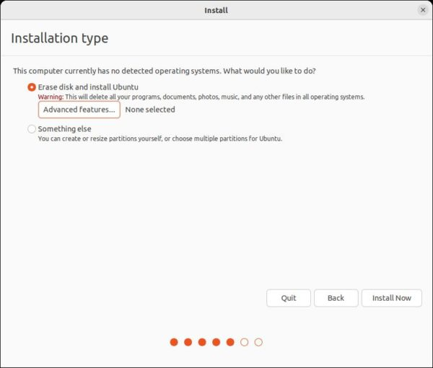

### **Step 6: Setup Account, Location and done**

After click “Install Now” and confirm on pop-up dialog. The wizard will prompt to set up your account, computer name, and select location.

You may add more accounts after installation, and other information can be changed later. So just do the settings as you prefer.

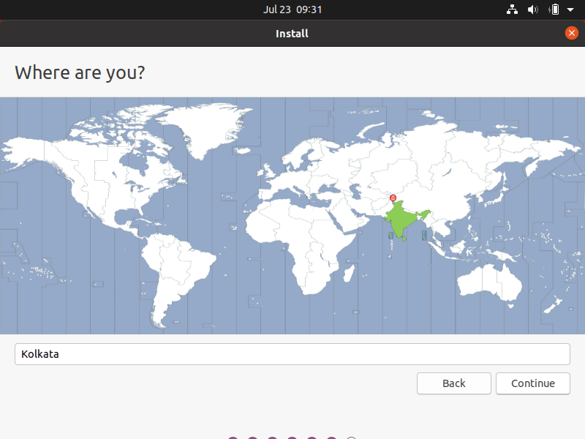

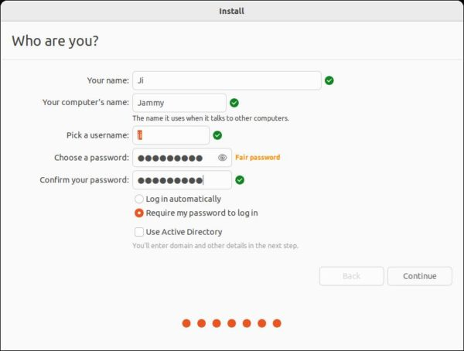

Finally, wait the process done. If no error occur, it should prompt installation done with option to restart your computer.

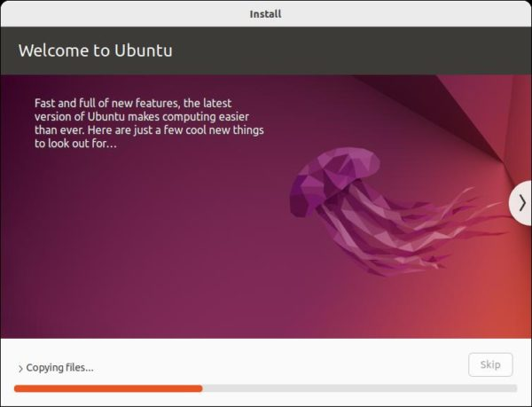

**Post-Installation Steps:**

After installing Ubuntu, you may want to install updates and additional software packages using the Software Updater and Ubuntu Software Center.

You can also customize your desktop environment, install drivers, and configure system settings according to your preferences.

**How To run Ubuntu on Hyper-V**

To run Ubuntu on Hyper-V, you'll need to create a virtual machine (VM) and install Ubuntu as the guest operating system. Here's a step-by-step guide to running Ubuntu on Hyper-V:

**1. Install Hyper-V:**

If you haven't already installed Hyper-V on your Windows machine, follow these steps:

**Press the Windows key**, type "Turn Windows features on or off," and press Enter.

In the Windows Features window, locate "Hyper-V" and check the box next to it.

Click OK and follow the prompts to install Hyper-V.

Restart your computer if prompted.

**2. Create a Virtual Machine:**

Open Hyper-V Manager:

Press the Windows key, type "Hyper-V Manager," and press Enter.

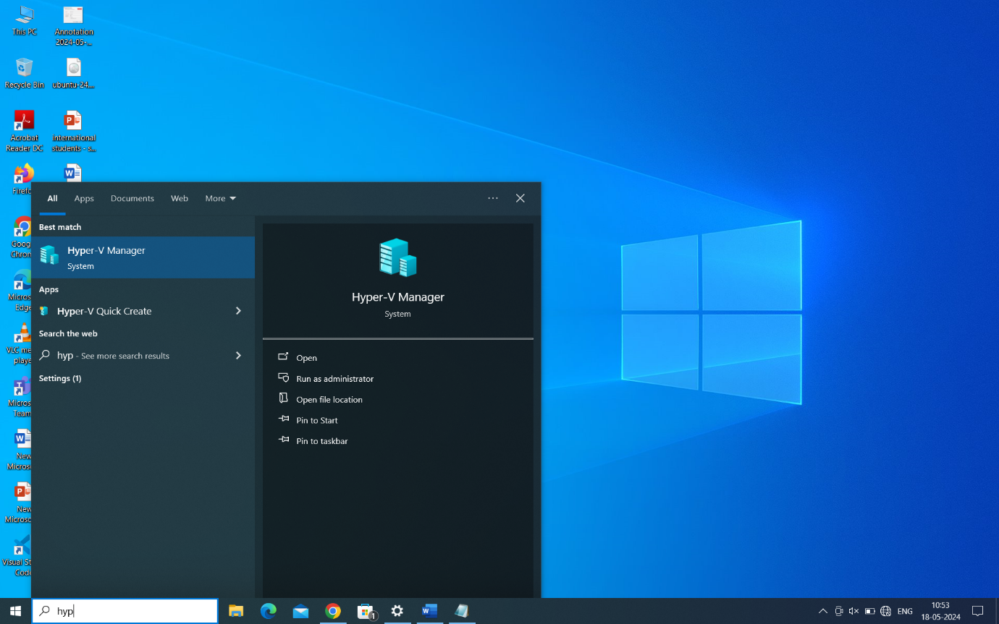

In Hyper-V Manager, click on your Hyper-V server in the left pane.

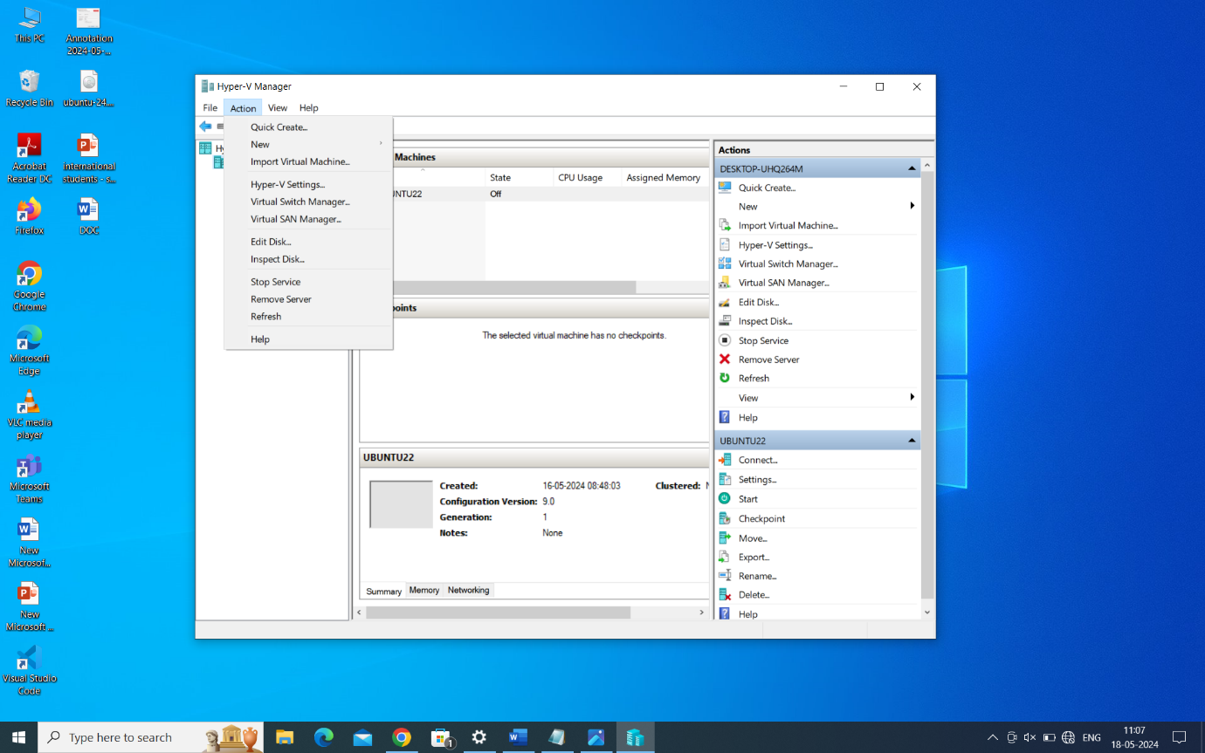

Under the Actions pane on the right, click on "New" and then "Virtual Machine."

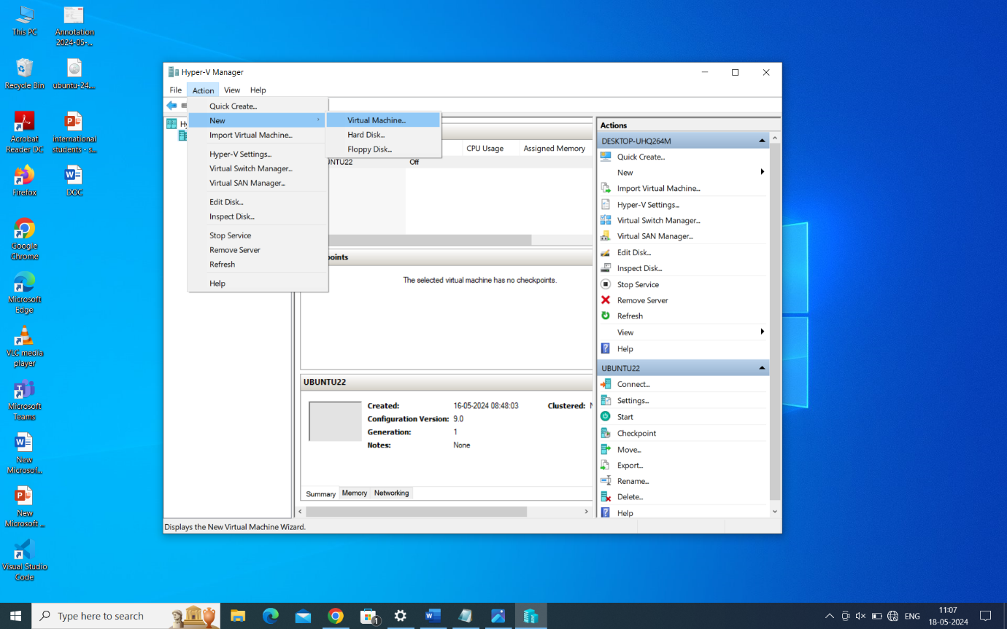

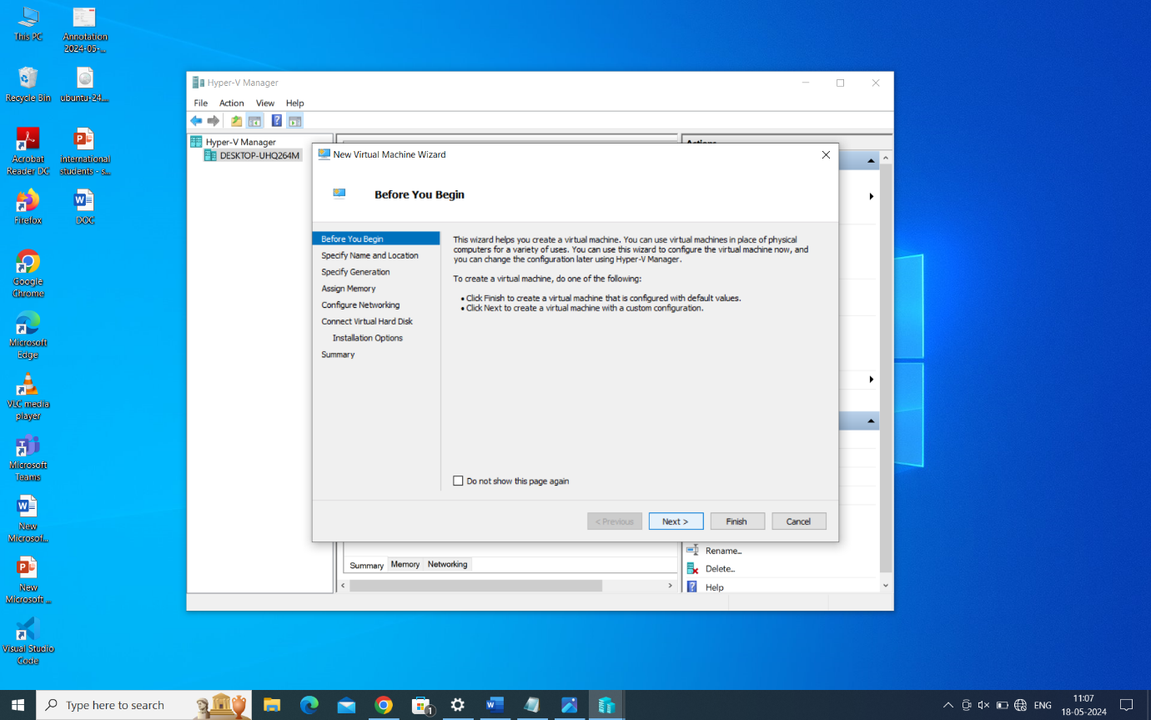

**Follow the New Virtual Machine Wizard to create a new VM:**

Specify a name for the VM.

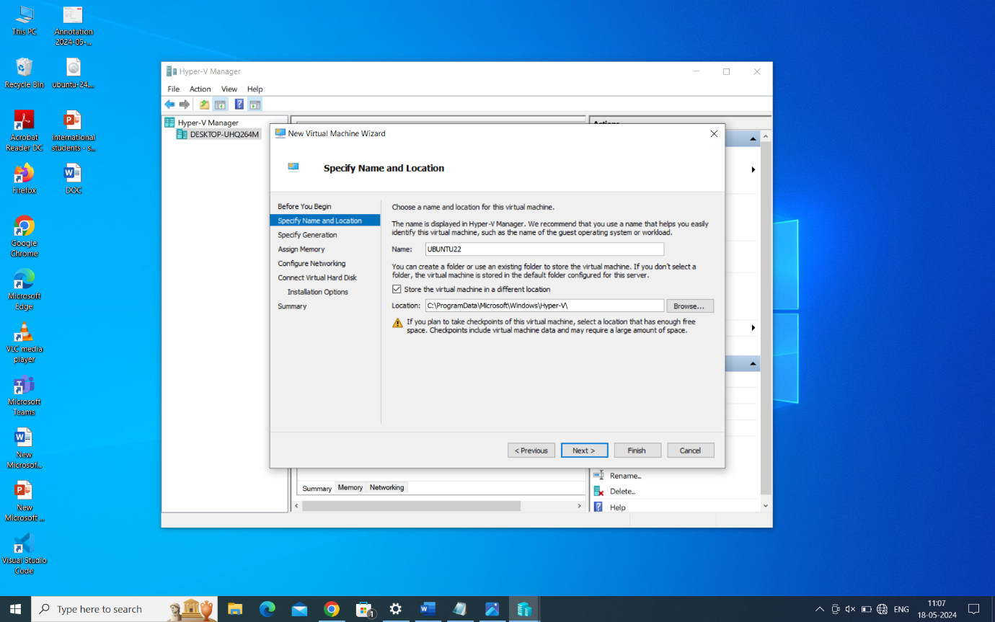

Choose a location to store the VM files.



Configure generation (Generation 1 or Generation 2).

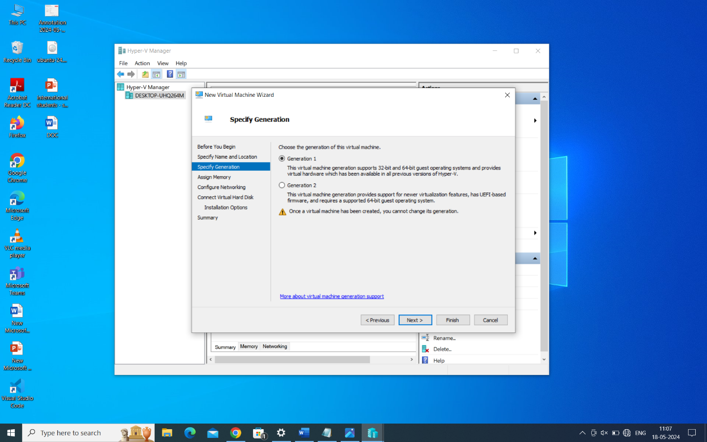

Allocate memory (RAM) to the VM.

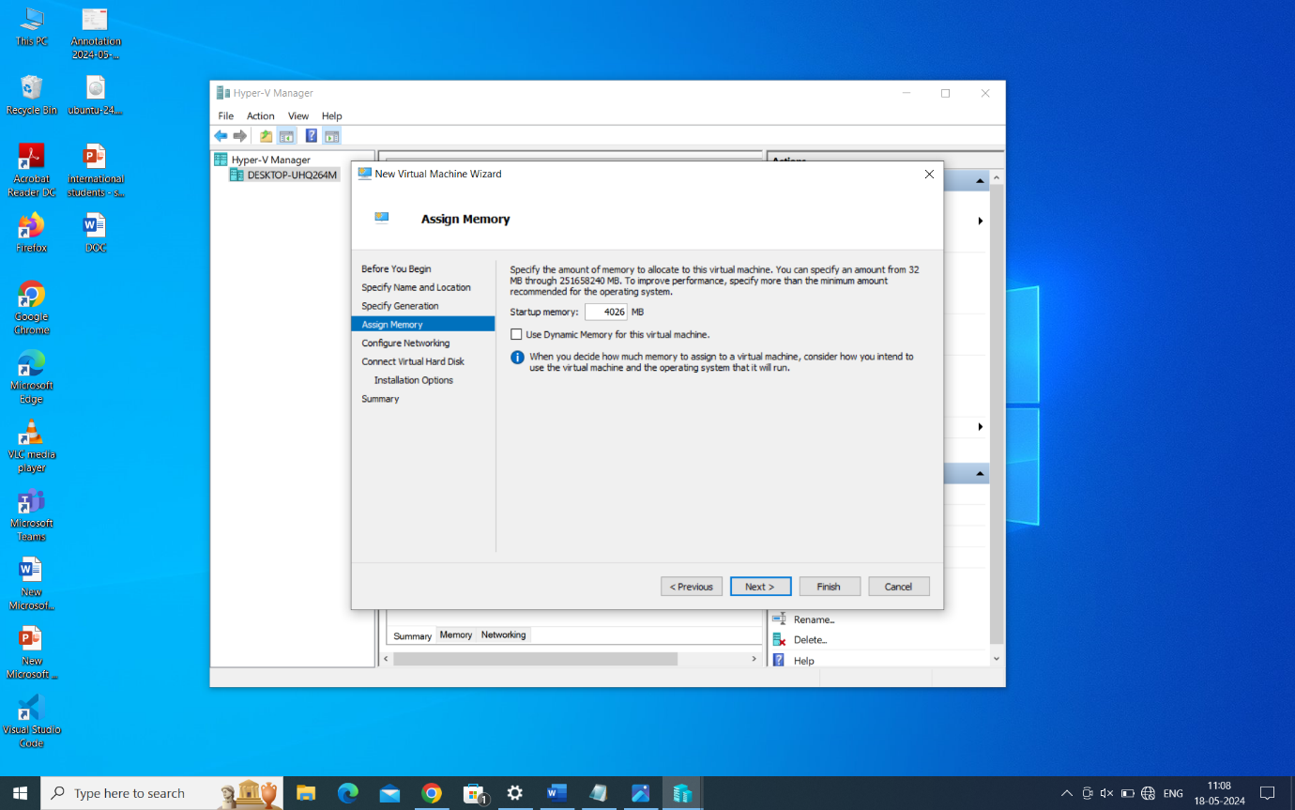

Configure networking (connect to a default switch from the drop down menu).

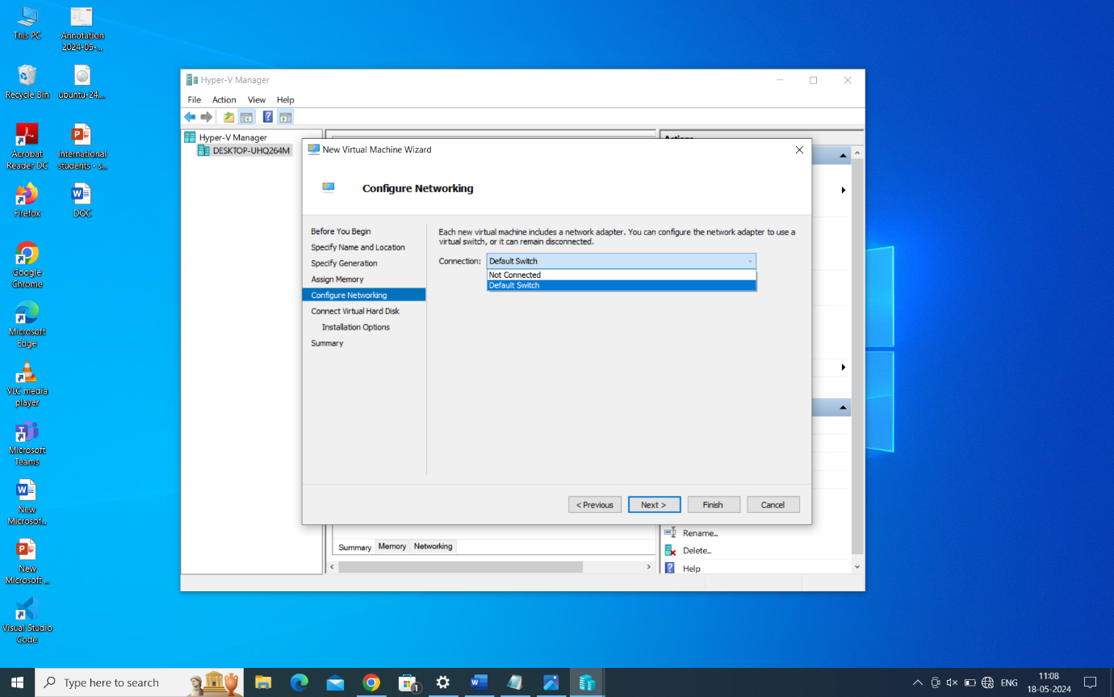

Create a virtual hard disk and specify its size.

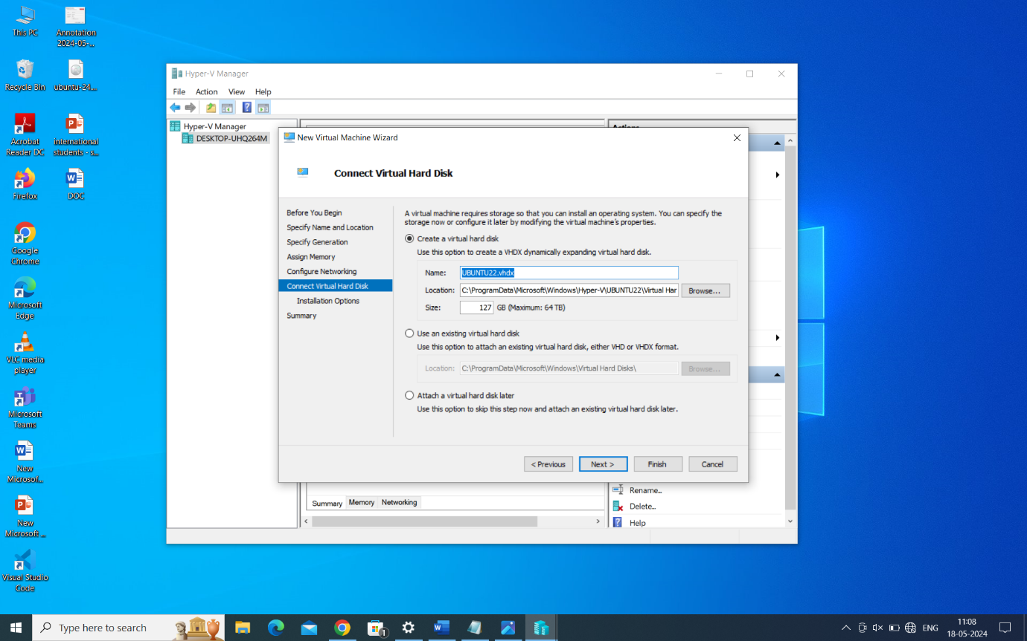

Choose an installation option (install an operating system later).

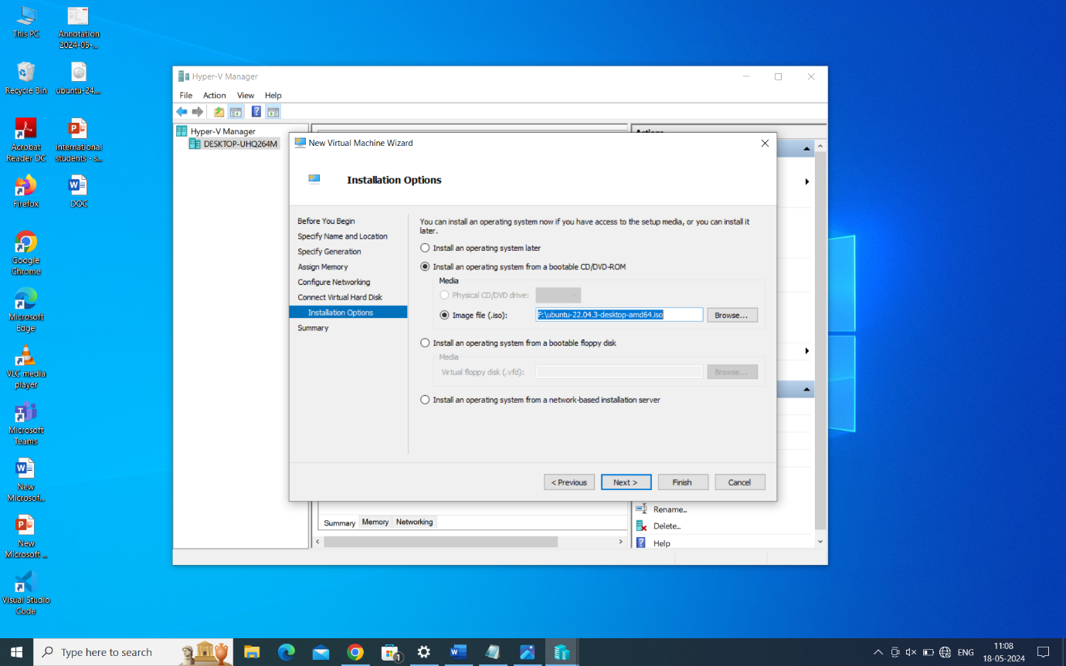

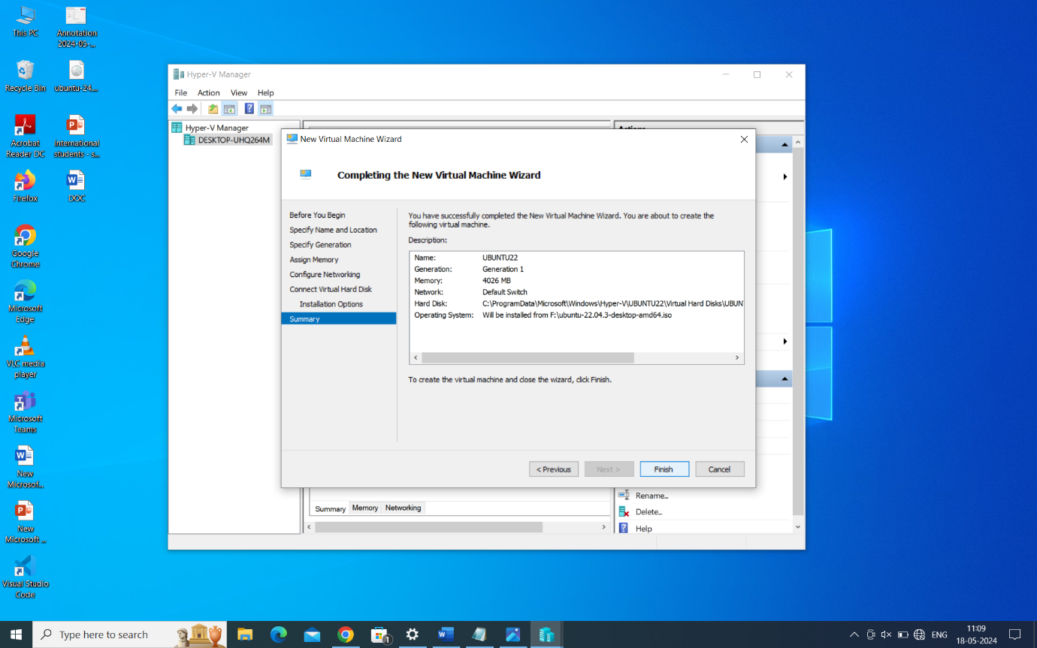

**3. Install Ubuntu on the Virtual Machine:**

**Download Ubuntu ISO:**

Go to the official Ubuntu website (https://ubuntu.com/download) and download the Ubuntu Desktop ISO.

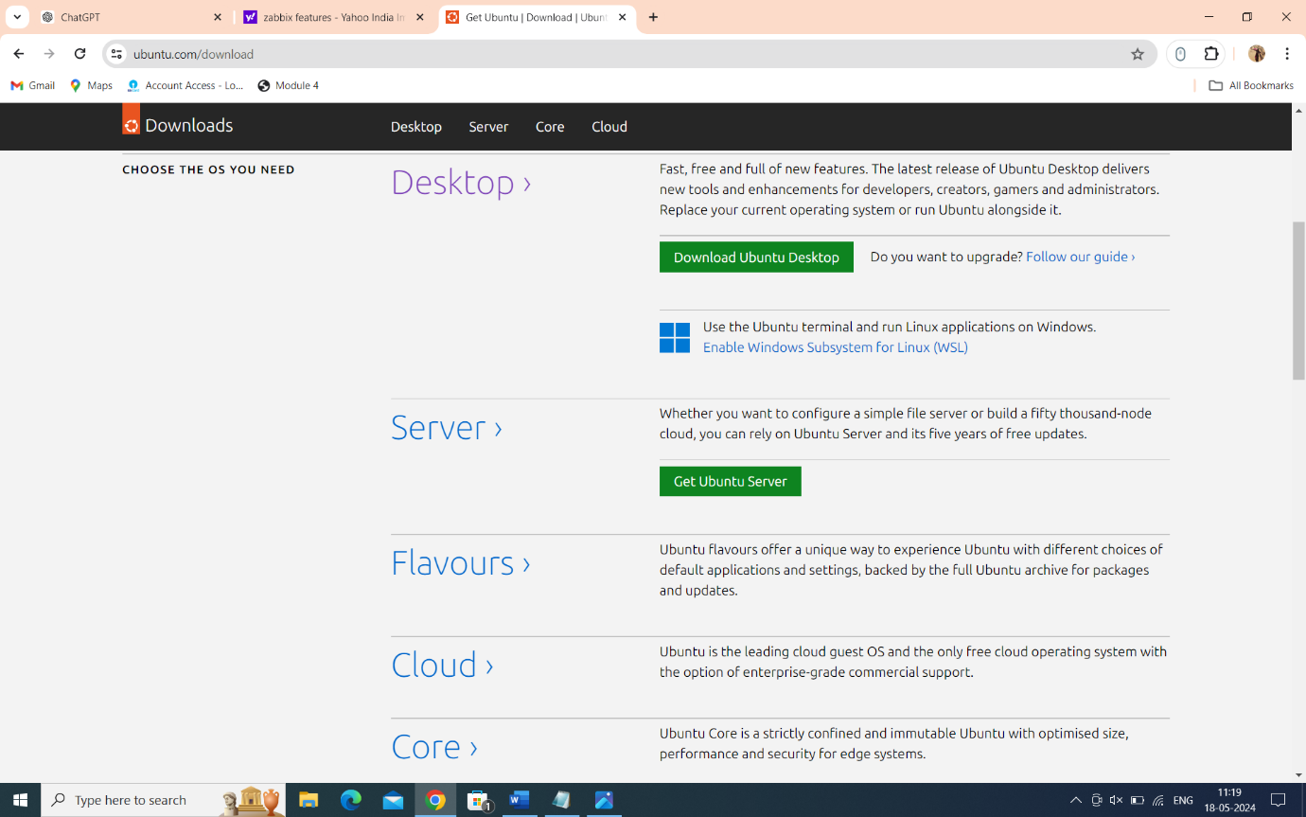

Attach the Ubuntu ISO to the VM:

In Hyper-V Manager, right-click on the Ubuntu VM and select "Connect."

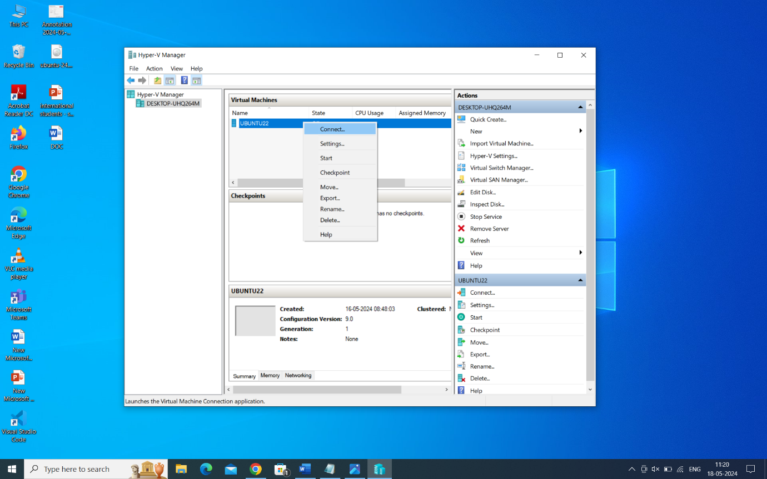

In the VM Connection window, click on the "Media" menu and select "Insert Disk."

Choose the downloaded Ubuntu ISO file.

Start the VM:

In Hyper-V Manager, right-click on the Ubuntu VM and select "Start."

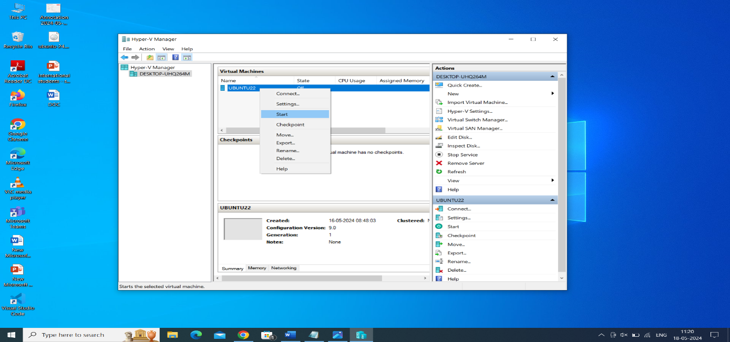

Install Ubuntu:

The VM will boot from the Ubuntu ISO. Follow the on-screen instructions to install Ubuntu.

Choose the installation language and click Install Ubuntu.

Follow the installation wizard to complete the installation process, including setting up language, time zone, keyboard layout, disk partitioning, and creating a user account.

**4. Post-Installation Steps:**

After Ubuntu is installed and the VM restarts, log in to the Ubuntu desktop using the credentials you created during installation.

**Update Ubuntu:**

Open a terminal in Ubuntu and run the following commands to update the system:

**commands**

**sudo apt update**

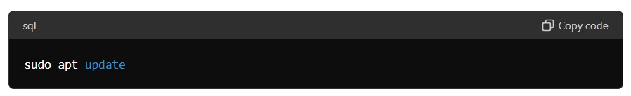

**sudo apt upgrade**

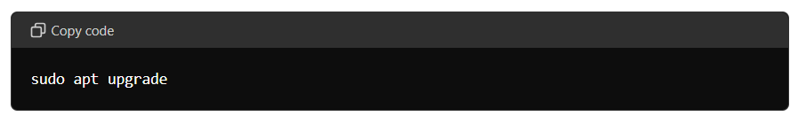

Configure additional software and settings as needed.

Now Ubuntu running on Hyper-V. You can use this virtual machine for development, testing, or any other purposes you need.

**CONFIGURING LINUX FOR ZABBIX**

Configuring Linux for Zabbix involves setting up the necessary environment to run the Zabbix server, which includes installing required software, configuring database settings, setting up the Zabbix server, and optionally configuring agents on monitored hosts. Here's a step-by-step guide:

**System Requirements:**

Ensure your Linux system meets the minimum requirements for running Zabbix. This typically includes sufficient CPU, RAM, and disk space.

Zabbix is compatible with various Linux distributions, including Ubuntu, CentOS, Debian, and others.

**Install Dependencies:**

* Install necessary dependencies such as Apache, PHP, MySQL (or PostgreSQL), and other required libraries:

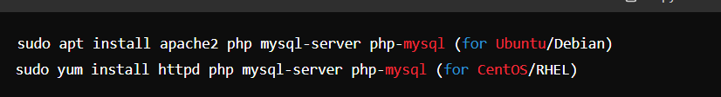

**Database Configuration:**

Create a database and user for Zabbix in MySQL or PostgreSQL: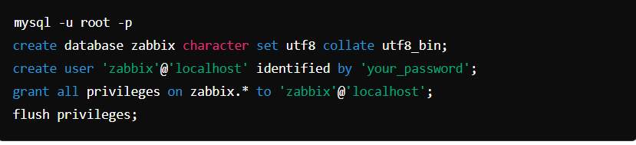

**Download and Install Zabbix:**

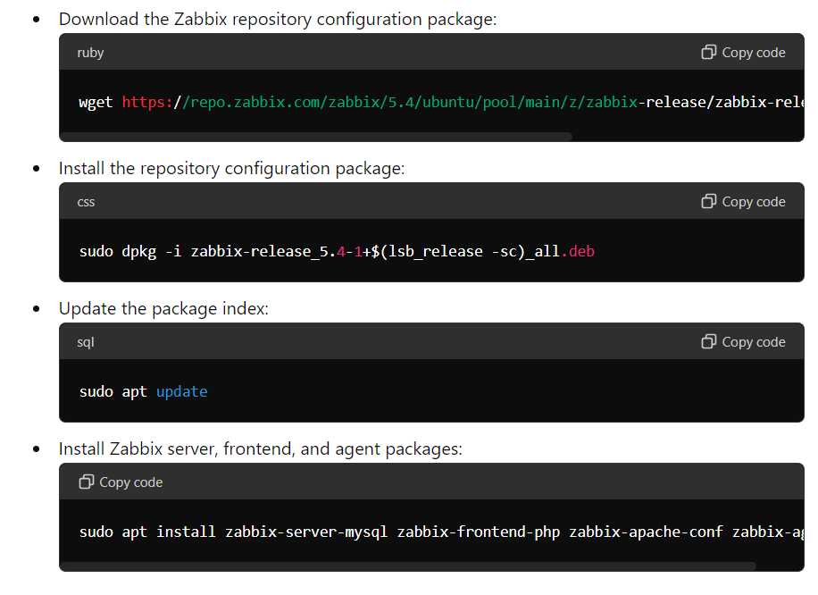

**Configure Zabbix Server:**

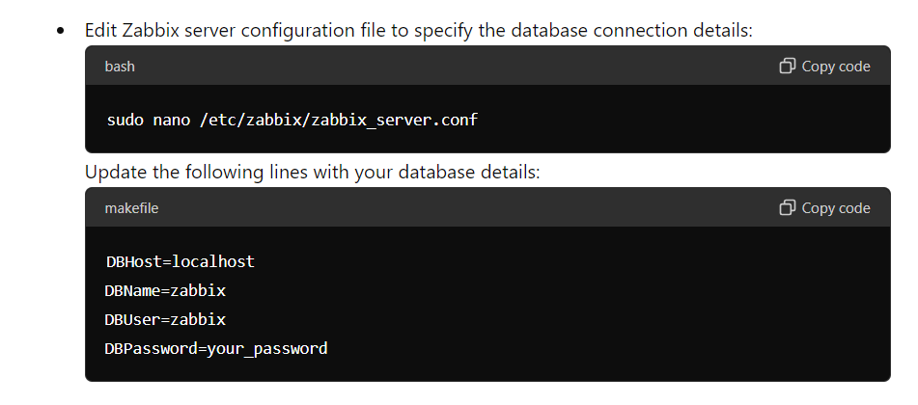

**Initialize Zabbix Database:**

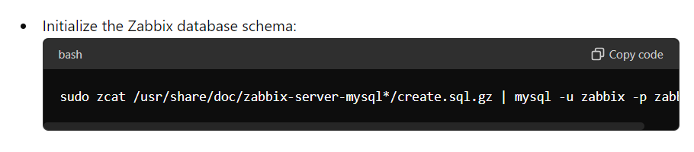

**Start Zabbix Server:**

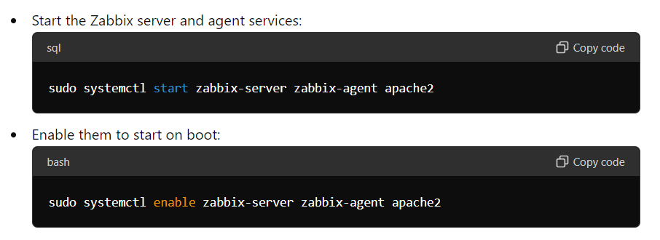

**Access Zabbix Web Interface:**

Open your web browser and navigate to http://your_server_ip/zabbix.

Follow the web-based setup wizard to configure Zabbix. Provide necessary details such as database connection settings, Zabbix server details, and login credentials.

**Configure Monitoring:**

Configure hosts, items, triggers, and other monitoring parameters through the Zabbix web interface.

Install Zabbix agents on hosts you wish to monitor and configure them to communicate with the Zabbix server.

You've now configured Zabbix on your Linux system for monitoring your infrastructure.

**Login to Zabbix Web Interface:**

Open your web browser and navigate to the URL where you installed Zabbix. Usually, it's something like http://your_server_ip/zabbix.

Log in with the default credentials (Username: Admin, Password: Zabbix)

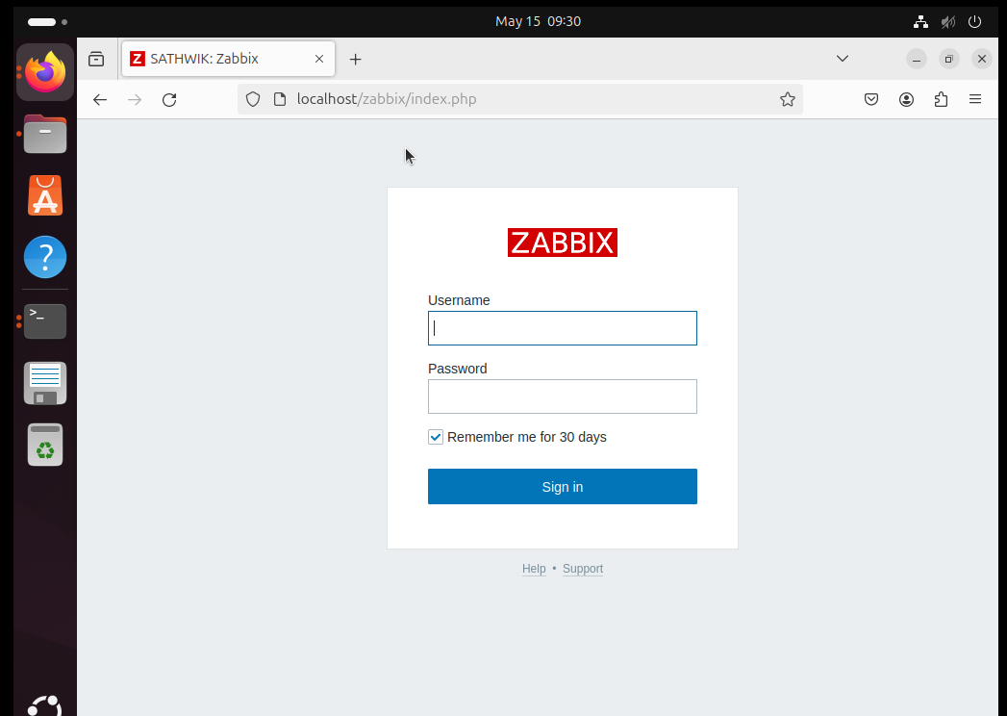

**Add Hosts:**

Click on "Configuration" in the top menu, then select "Hosts".

Click on the "Create host" button.

Fill in the necessary information about the host you want to monitor, like Host name, Visible name, and IP address.

Go to the "Templates" tab and link the host to the templates relevant to your monitoring needs (like Linux servers, Windows servers, etc.).

Click "Add" to save the host.

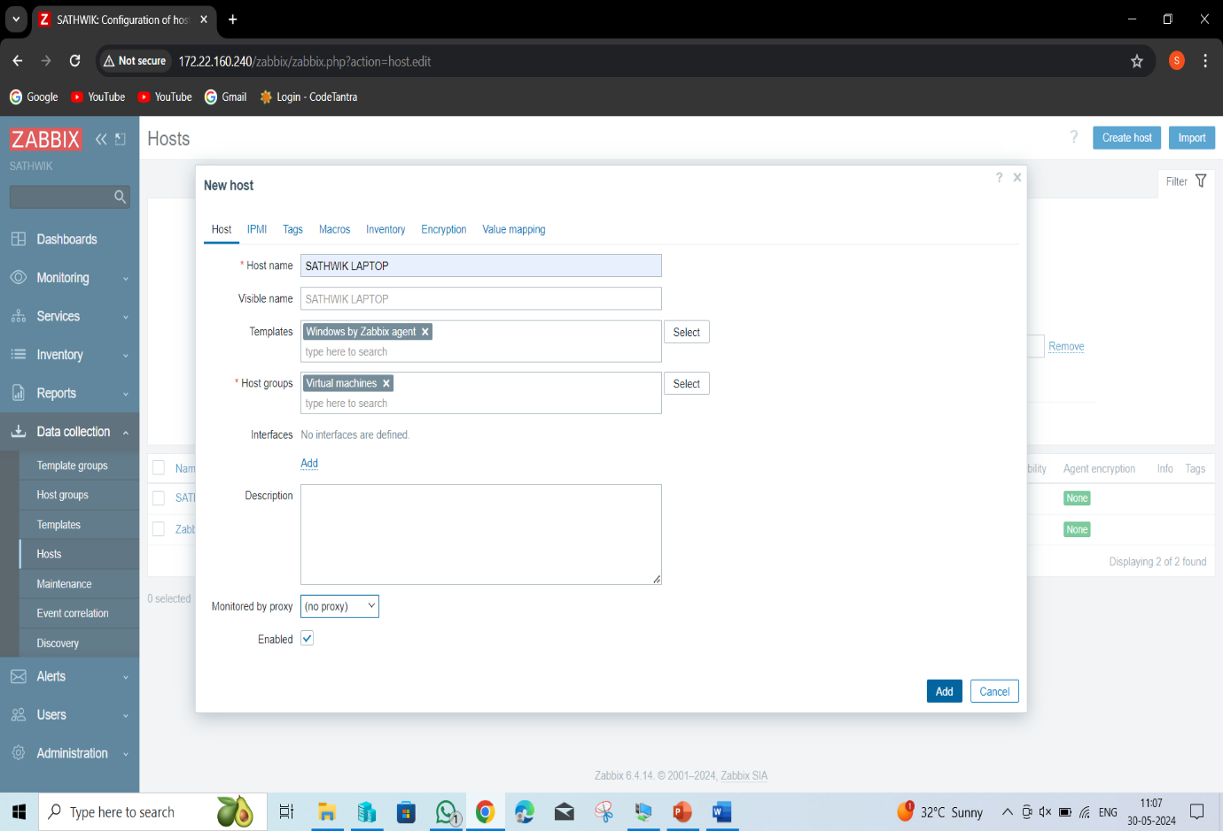

**View Monitoring Data:**

After adding hosts, you can view monitoring data in various ways:

Monitoring Overview: Click on "Monitoring" in the top menu to see an overview of monitored hosts and their status.

Host Status: Under "Monitoring", select "Hosts" to view a list of all monitored hosts and their status.

Graphs: Click on "Graphs" under "Monitoring" to view graphs of monitored items over time.

Latest Data: Navigate to "Monitoring" > "Latest data" to see the latest values of monitored items.

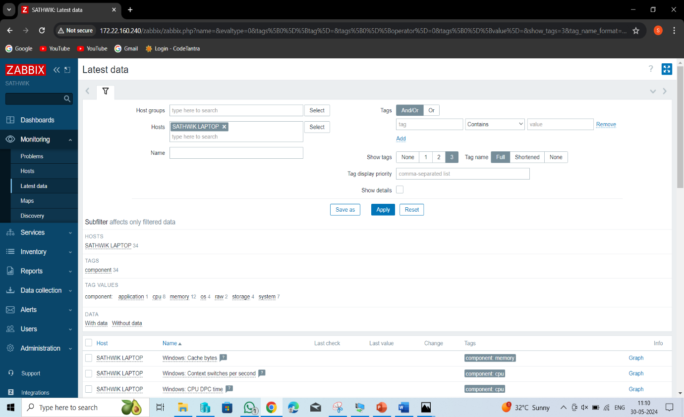

**Create Triggers :**

Triggers are conditions that, when met, generate alerts. You can create triggers based on the monitored items' values.

Go to "Configuration" > "Triggers" to create new triggers. Define conditions and severity levels for the triggers.

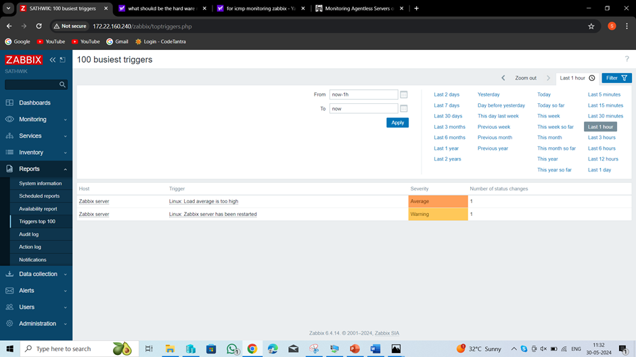

**View Alerts :**

If triggers are configured, you can view alerts generated by triggers that have been activated.

Navigate to "Monitoring" > "Problems" to see a list of current problems and their severity.

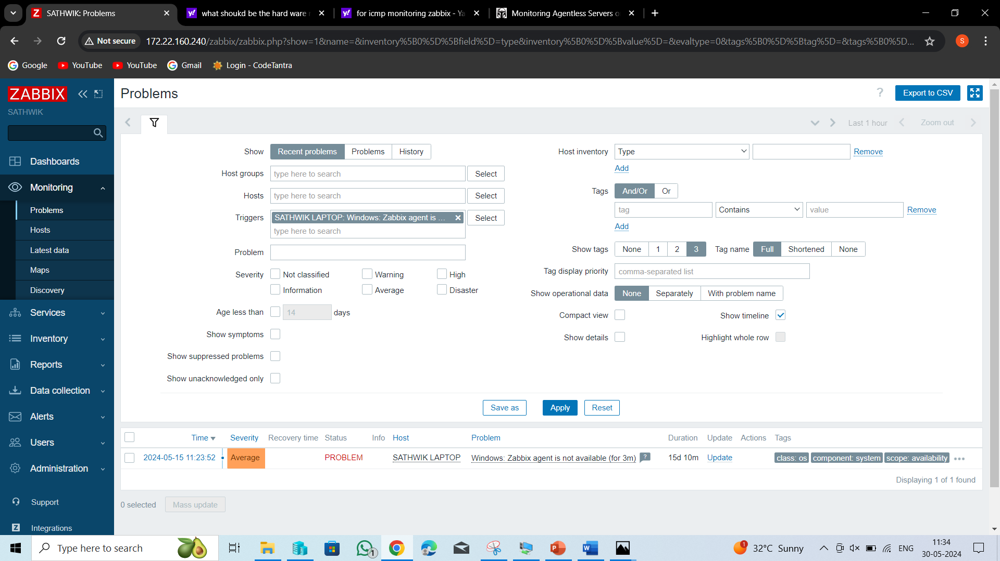

**Customize Dashboards** :

You can customize dashboards to display the information relevant to you or your team.

Click on "Dashboard" in the top menu to create or customize dashboards with widgets displaying graphs, maps, or other visualizations.

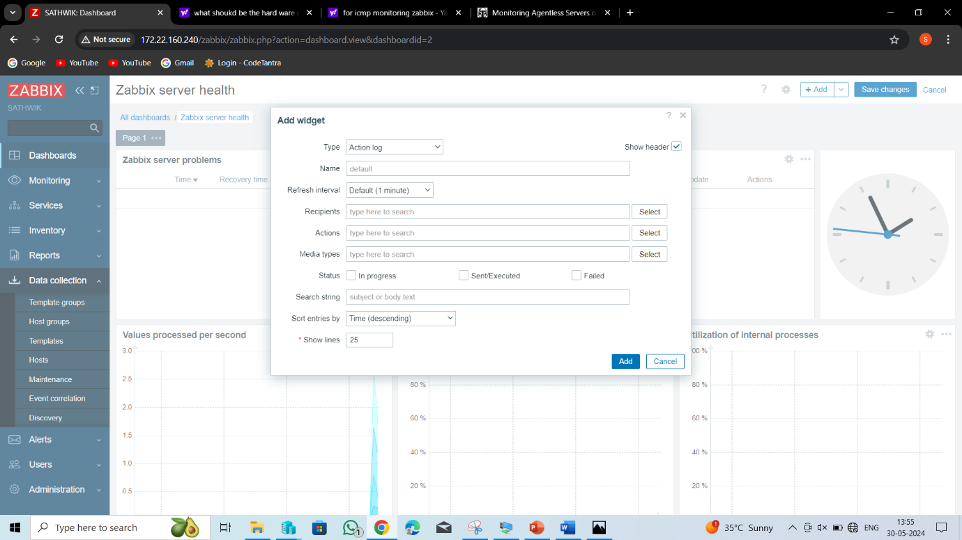

Updated!

**Set Up User Access:** grant

Manage user roles and access permissions to restrict or access to specific features or hosts.

Go to "Administration" > "Users" to manage user accounts and permissions.

These steps should help you get started with monitoring and viewing data in Zabbix. Remember that Zabbix is highly customizable, so you can tailor it to your specific monitoring requirements and preferences.

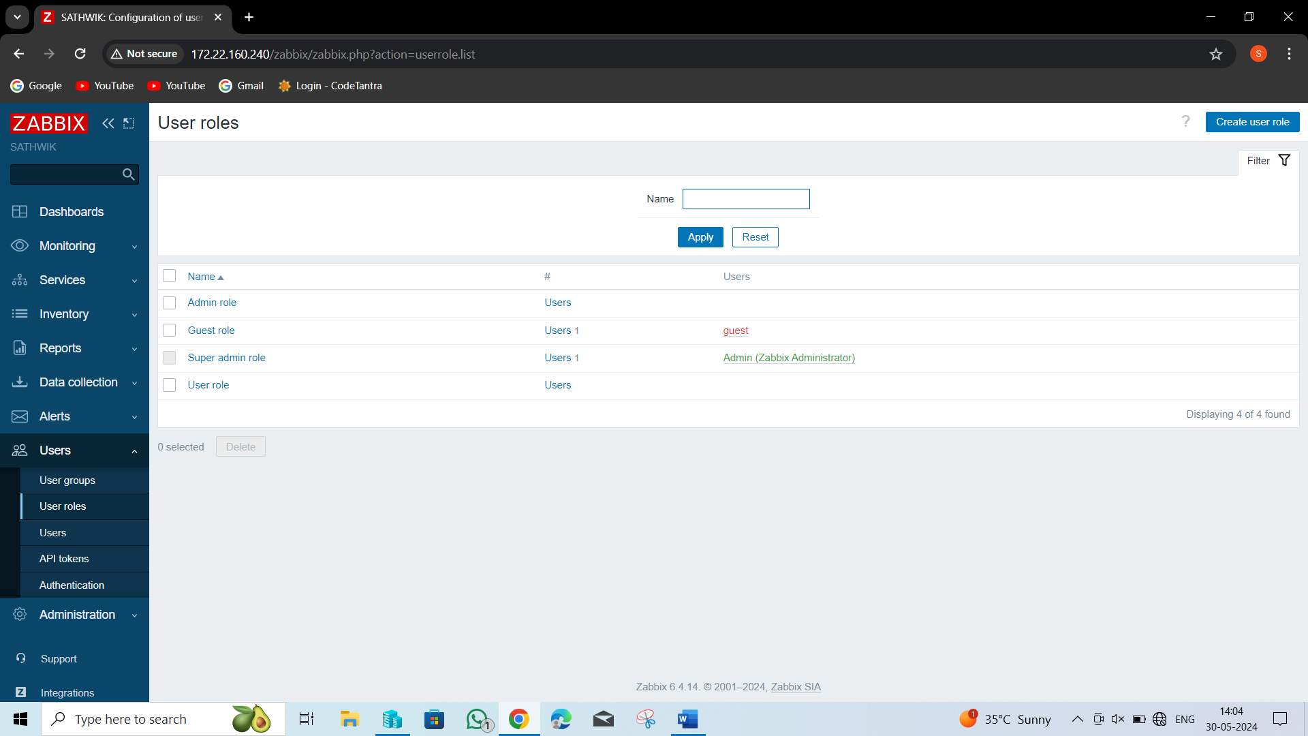

**PERFORMANCE TUNING FOR MYSQL**

**Zabbix and MySQL**

Half of the Zabbix installations are running on MySQL. However, Zabbix is quite a write-intensive application, so we need to optimize the database configuration and usage to work smoothly with Zabbix that reads the database and writes to the database a lot.

**Optimizing MySQL for Zabbix**

Balancing the load on several disks

So, how can we optimize MySQL configuration to work with Zabbix? First of all, it is very important to balance the load on several hard drives by using:

**datadir** to specify the default location, that is to dedicate the hard drives to the data directory;

**datadir innodb_data_file_**path to define size, and attributes of InnoDB system tablespace data files;

**innodb_undo_directory** to specify the path to the InnoDB undo tablespaces;

**innodb_log_group_home_dir** to specify the path to the InnoDB redo log files;

**log-bin** to enable binary logging and set path/file name prefix (dual functionality); and

**VIEWING YOUR MYSQL CONFIGURATION**

Now, we can jump straight to MySQL configuration. It is important to start from your current configuration and check who and when has changed this configuration.

command

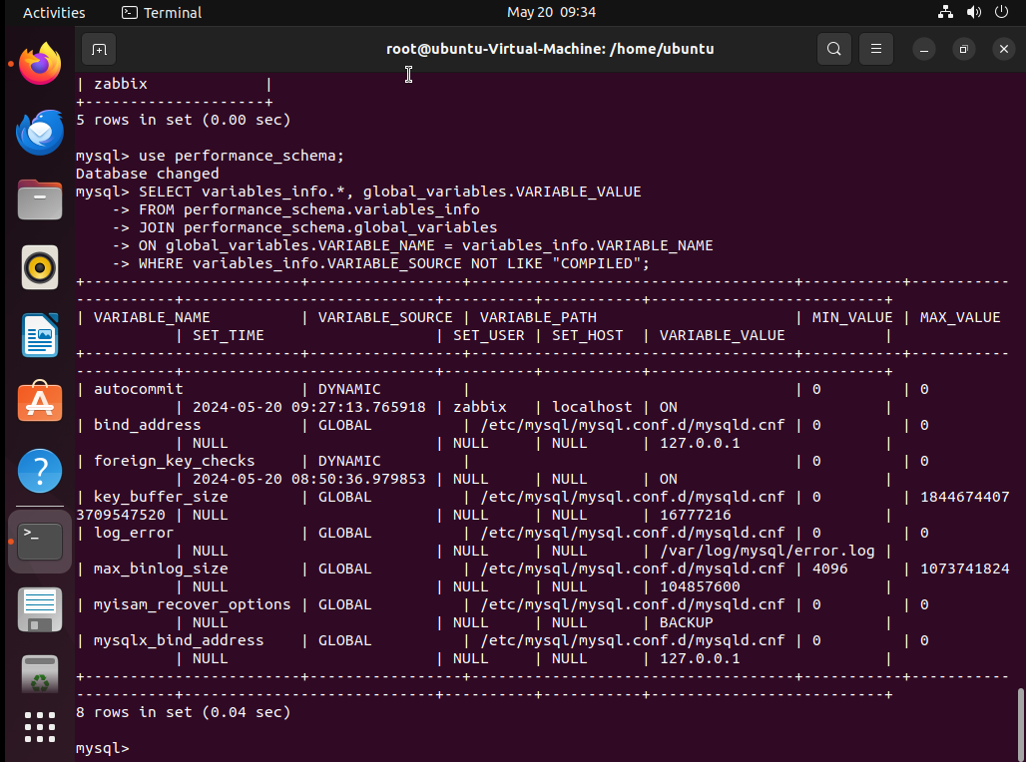

This query can help you to understand who has changed the configuration. However, when the configuration is changing is also important to keep track of these changes.

**VIEWING MYSQL CONFIGURATION**

MySQL key variables to optimize in your configuration

**InnoDB buffer pool**

The king of all of the variables to be optimized is InnoDB buffer pool, which is the main parameter determining the memory for storing the DB pages — MySQL buffer pool — an area in main memory MySQL where InnoDB caches table and index data as it is accessed.

InnoDB default value is to log, for production 50-75% of available memory on the dedicated database server.

**TO CHECK INNODB BUFFER POOL USAGE (IN %)** AND if you need to allocate more memory for the InnoDB Buffer Pool, you can use the query, which allows you to see the current usage as a percentage (though there are many queries to monitor the InnoDB Buffer Pool).

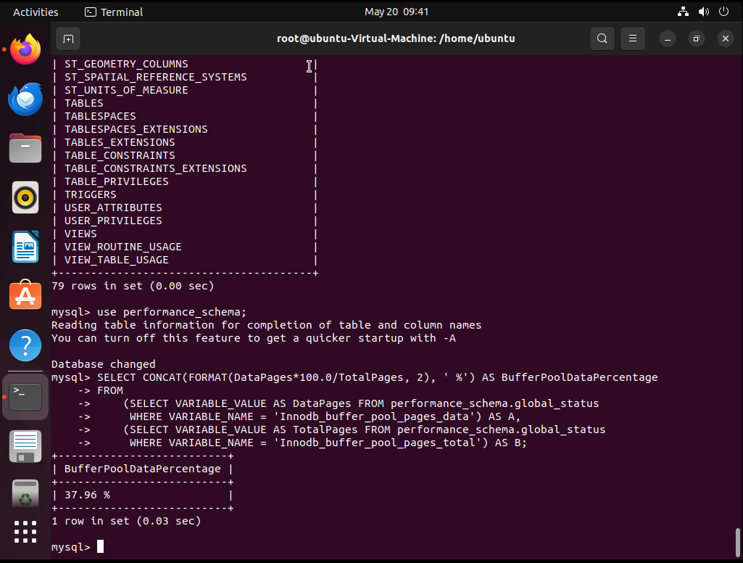

**BINARY LOGS**

Binary logs contain events that describe changes, provide data changes sent to replicas, and are used for data recovery operations.

If you work with replication, you might know that binary logs require special attention apart from having them on a separate disk. You should size the binary logs properly, set the proper expiration time (1 month by default), and the maximum size, for instance, of 1 GB so that you will be able to write 1 GB of data per day.

We can have about 30 log files in the binary logs. However, you should check the activities of your system to consider increasing this number, as well as the expiration of the binary logs, if you need to keep more data for operations, such as finding time recovery, for instance.

**PURGE BINARY LOGS TO|BEFORE** to delete all the binary log files listed in the log index file prior to the specified log file name or date.

In addition, consider using GTID for replication to keep track of transactions.

**INNODB REDO LOGS**

This is yet another beast, which we want to keep control of — the redo and undo logs, which get written prior to flushing the data to the disk.

**INNODB_LOG_FILE_SIZE**

– The size of redo logs will impact the writing speed over the time to recover.

– The default value is too low, so consider using at least 512 MB for production.

**TRADING PERFORMANCE OVER CONSISTENCY (ACID)**

Associated with the redo and undo log discussion is the trading performance over consistency discussion about when InnoDB should flush/sync committed truncations.

0 — transactions are written to redo logs once per second;

1 — (default value) fully ACID-compliant with redo logs written and flushed to disk at transaction commit;

2 — transactions are written to redo logs at commit, and redo logs are flushed once per second.

If the system is write-intensive, you might consider setting this value to 2 to keep redo logs at every commit with the data written to disk once per second. This is a very good compromise between data integrity and performance successfully used in a number of write-intensive setups. This is a relief for the disk subsystem allowing you to gain that extra performance.

**CONCLUSION**

Now, you are ready to fine-tune your configuration step by step, starting from innodb_buffer_pool, max_connections, and table_open_cache, and see if your performance improves. Eventually, you can do further analysis and go further to really fine-tune your system up to your needs.

In general, 3-5 core parameters would be enough for operating with Zabbix in the vast majority of cases. If you tune those parameters keeping in mind dealing with a write-intensive application, you can achieve good results, especially if you separate the resources at a hardware level or at a VM level.

**Performance tuning dos and don’ts**

For a high-level performance tuning 101, think carefully and consider the whole stack together with the application.

In addition, think methodically:

define what you are trying to solve, starting from the core of variables, which you want to fine-tune;

argue why the proposed change will work;

create an action plan; and

verify the change worked.

**To make things work:**

— don’t micromanage;

— do not optimize too much;

— do not optimize everything; and, most importantly,

— do not take best practices as gospel truth, but try to adjust any practices to your particular environment.



**ZABBIX PERFORMANCE TUNING**

**1 Performance tuning**

Zabbix performance tuning Zabbix data flow Visualization Database Notifications ZABBIX Server History Analysis Data collection.

Zabbix performance tuning How to measure performance Number of values processed per second (NVPS)

A rough estimate of NVPS is visible in Zabbix.

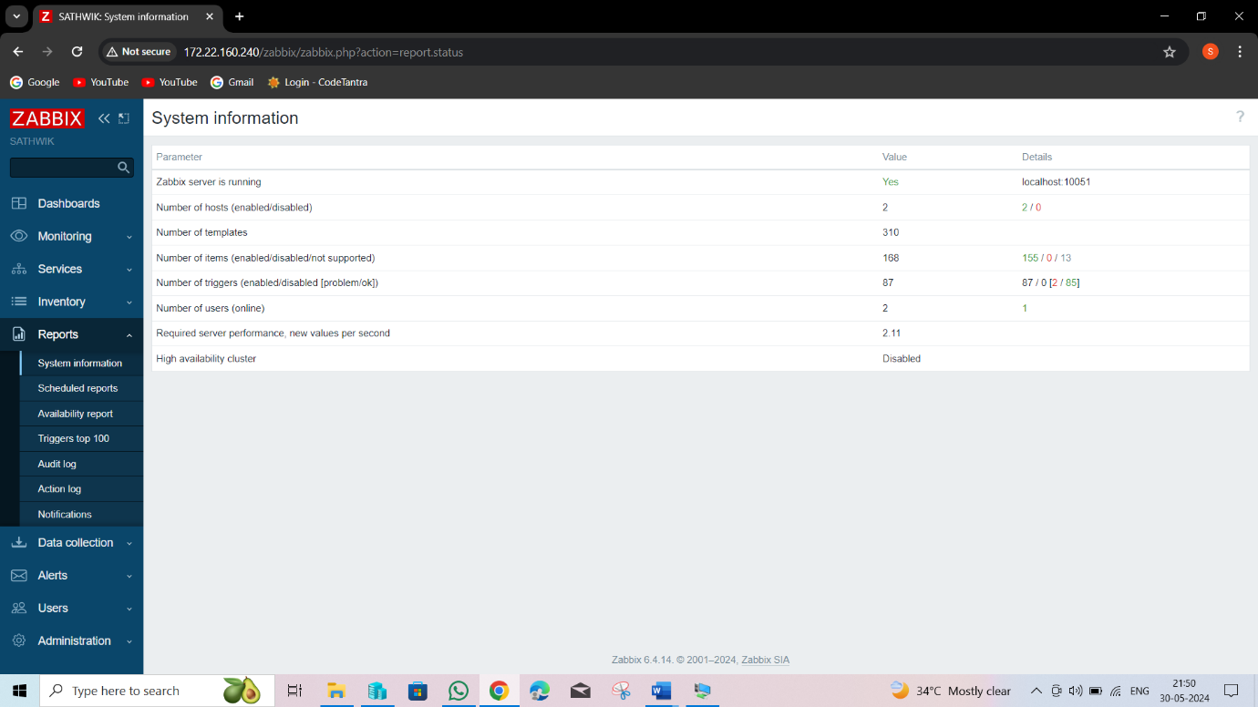

**FIG: System information**

Update frequency greatly affects NVPS. The calculation takes into account data from the monitored devices. Data types “Zabbix trapper” or “SNMP trap” are not taken into account.

**2 Performance**

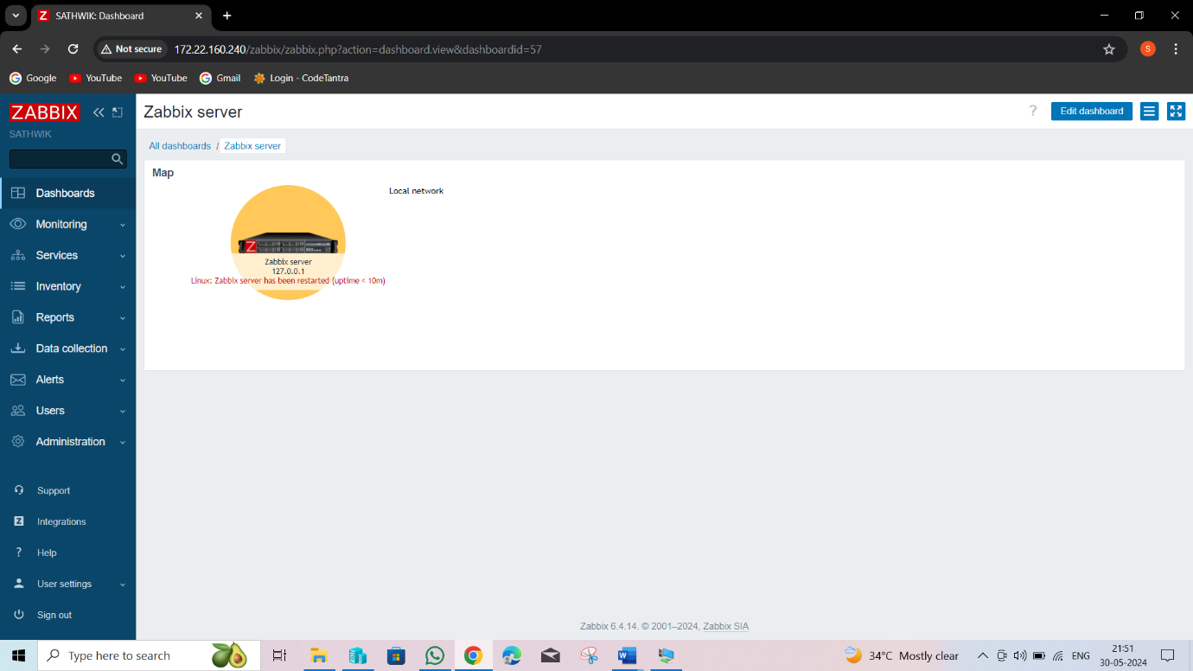

**FIG: Zabbix Server**

Zabbix is able to deliver 2 million of values per minute or around 30.000 of values per second In real life performance would be worse.

Affects performance

Type of items, value types, SNMPv3, number of triggers and complexity of triggers. Housekeeper settings and thus size of the database. Number of users working with the WEB interface.

Visible symptoms of bad performance Zabbix queue has too many delayed items Administration->Queue Frequent gaps in graphs, no data for some of the items False positives for triggers having no data () function Unresponsive WEB interface No alerts or thousands of alerts.

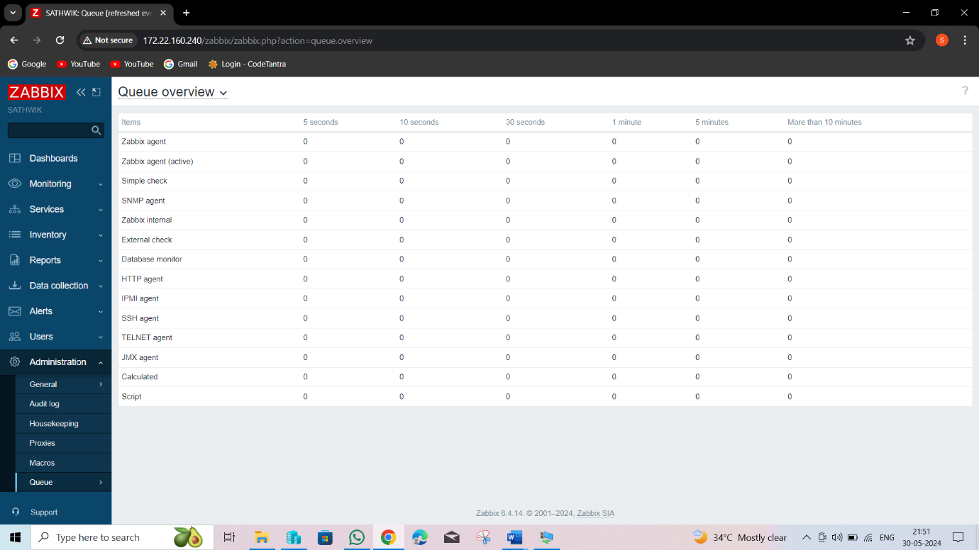

**FIG:** Nice view of queue of items

**3 Identify**

Main utilities top, ntop, iostat, vmstat, sar Zabbix itself strace or log file with debugging mode enabled ps aux | grep zabbix_server

#1 ps ax | grep sync history syncer #1 [synced 1020 items in 285.198752 sec, syncing history] history syncer

#2 [synced 915 items in 285.177799 sec, syncing history] history syncer

#3 [synced 3401 items in 284.936376 sec, syncing history] history syncer

#4 [synced 1194 items in 285.280719 sec, syncing history

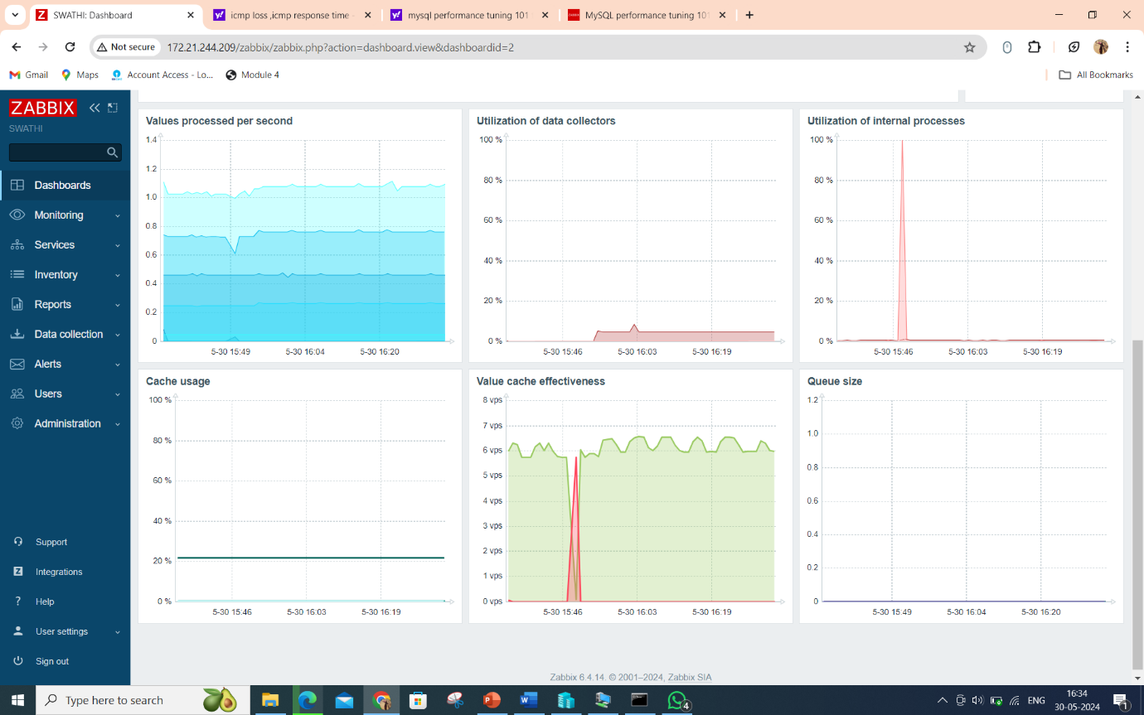

**FIG : Graphs**

Debug mode There is a problem, but it is not clear what kind of problem? Enable debugging mode for the process: # zabbix_server -R log_level_increase=alerter Search in the log for information about the problem (grep, etc.): /var/log/zabbix/zabbix_server.log.

Zabbix server configuration file, zabbix_server.conf

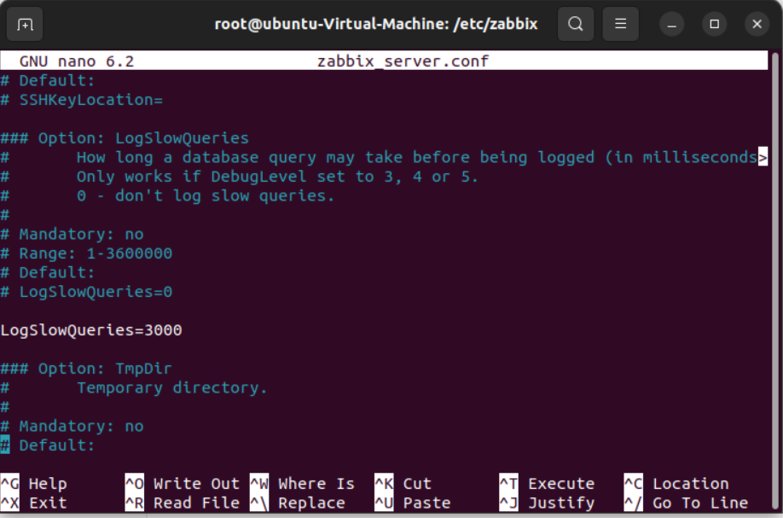 **FIG: Log slow queries**

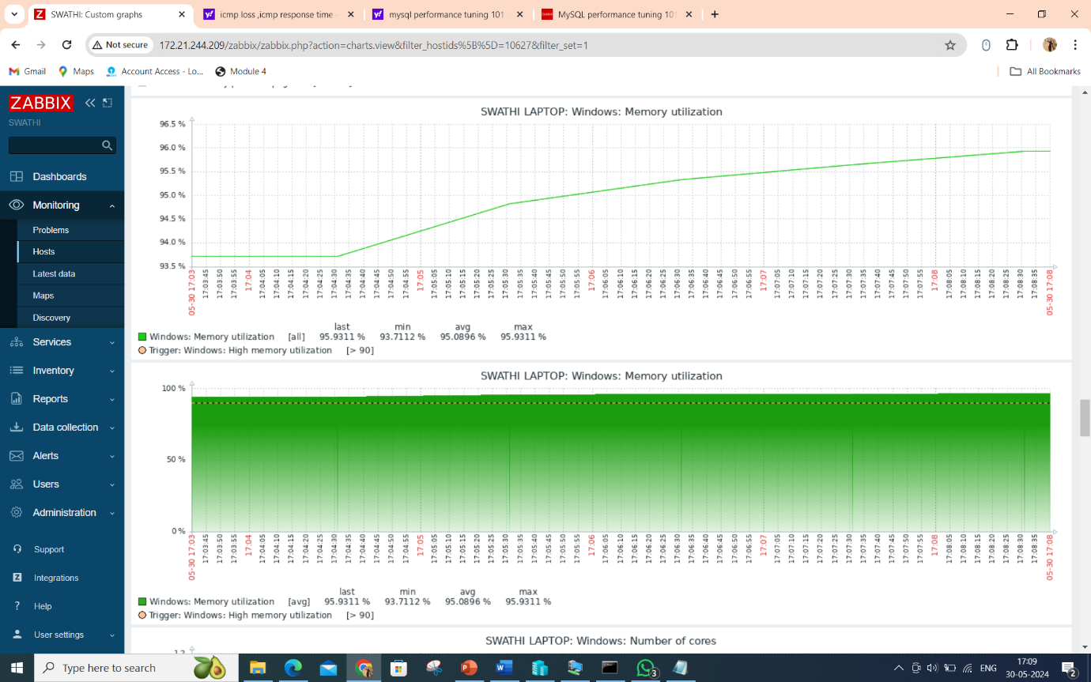

**FIG: Zabbix server performance**

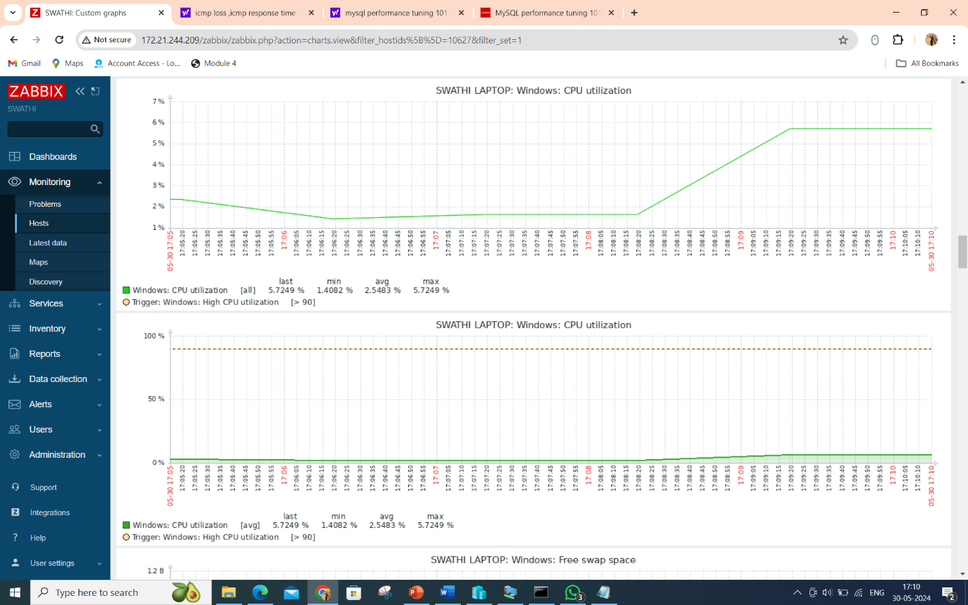

**FIG: Zabbix cpu utilization**

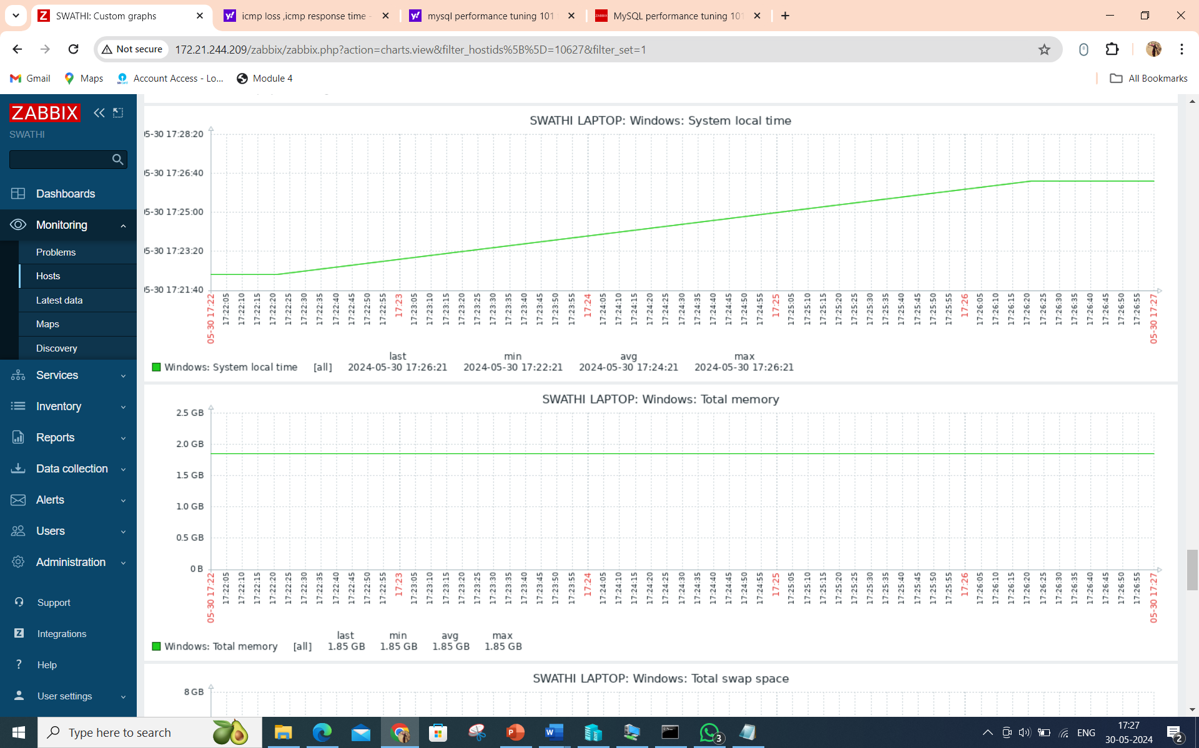

**FIG: systemlocaltime an totalmemory**

**Tune**

Tune number of processes (example) Zabbix server configuration file, zabbix_server.conf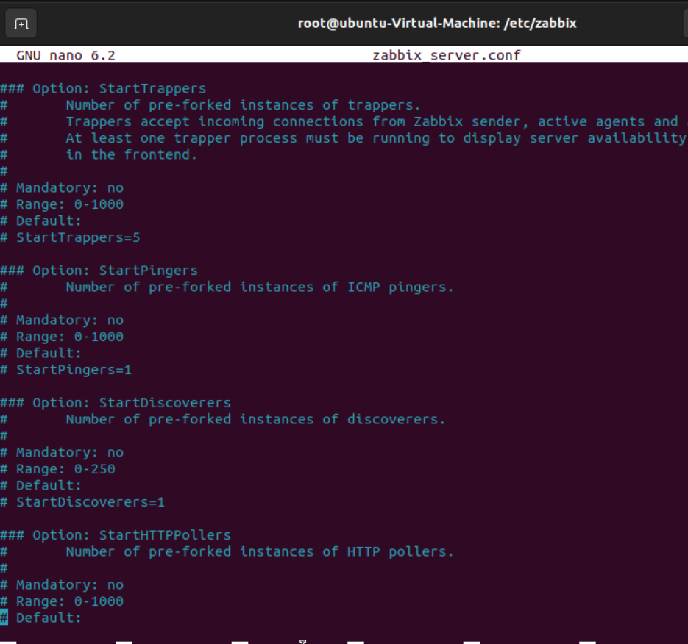

**FIG: Startpoller**

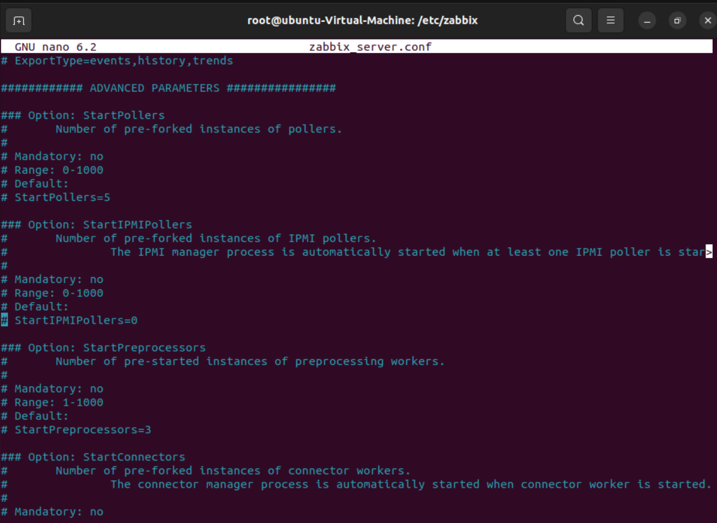

**FIG: Startconnector**

**4 Improve**

Table partitioning It is a way to split large tables into smaller partitions. Make sense for historical tables: history_* and trends* Benefits: Easy to remove older data Significantly better performance.Trigger “Zabbix housekeeper processes more than 75% busy” is in problem state for hours or days The performance of housekeeper is dropping. 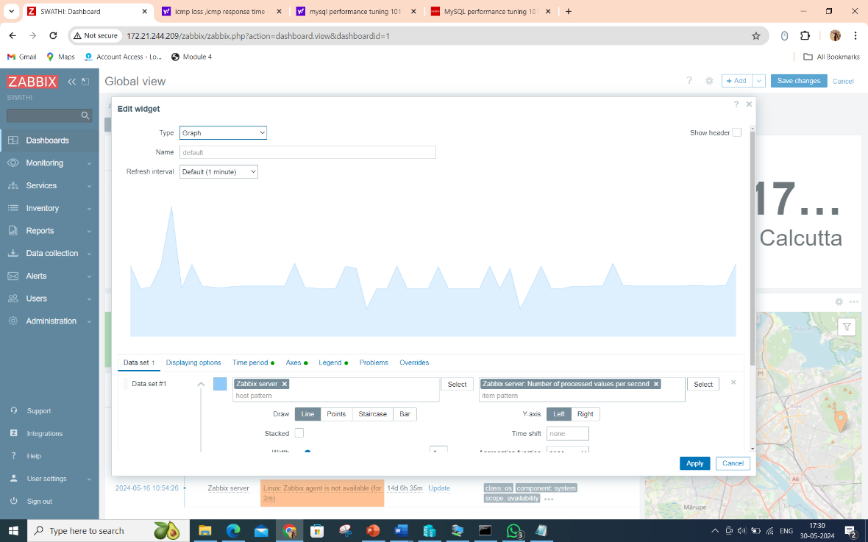

**Introduction to ICMP-based Network Device Monitoring in Zabbix**

ICMP-based monitoring using ping in Zabbix is a common agentless monitoring method. It checks the availability of remote servers, websites, or network devices by sending ICMP requests from the monitoring server. If there's no response, the response time is too long, or a large percentage of packets are lost, Zabbix displays a warning on the dashboard. ICMP is widely used for network host availability checks, and tools like ping and traceroute work over the ICMP protocol.

**CONFIGURING FIREWALL FOR ICMP PING**

On Windows Server

ICMP ping is allowed by default, but if it has been disabled, you can enable it using netsh or PowerShell.

Using netsh:

Run Command Prompt as an administrator.

Enter the following command:

cmd

**netsh advfirewall firewall add rule name="ICMP Allow" protocol=icmpv4:8,any dir=in action=allow**

Using PowerShell:

Open PowerShell as an administrator.

Enter the following command:

powershell

Set-NetFirewallRule -Name FPS-ICMP-ERQ-In -Enabled True -Profile Any -Action Allow

These commands create a firewall rule to allow inbound ICMP echo requests.

On Linux

ICMP traffic is usually allowed by default. If disabled, add these iptables rules:

Using iptables:

Run these commands under root or with sudo:

iptables -I INPUT -p icmp --icmp-type echo-request -j ACCEPT

iptables -I OUTPUT -p icmp --icmp-type echo-reply -j ACCEPT

Using firewalld:

Run this command to allow ICMP ping replies:

firewall-cmd --permanent --direct --add-rule ipv4 filter INPUT 0 -p icmp -s 0.0.0.0/0 -d 0.0.0.0/0 -j ACCEPT

Installing and Configuring Fping on Zabbix Server

Fping is used by Zabbix to perform ICMP checks.

**Check if Fping is installed:**

Run the following command on your Zabbix server:

fping -v

**Install Fping if not present:**

On Ubuntu:

apt install fping

On CentOS:

Connect to the EPEL repository.

Install Fping:

yum install fping

**Ensure the correct path:**

By default, Fping is installed in /usr/bin/fping.

If it is located elsewhere, update the zabbix_server.conf file:

FpingLocation=/usr/bin/fping

Fping6Location=/usr/bin/fping6

ICMP Ping Template in Zabbix

Zabbix includes a default template for ICMP ping monitoring.

**Template Features:**

ICMP ping: Checks node availability via ICMP.

ICMP loss: Measures the percentage of lost packets.

ICMP response time: Records ICMP ping response time in milliseconds.

Template Keys:

icmpping: Node availability.

icmppngloss: Packet loss percentage.

icmppingse: Response time.

These keys are Simple checks and do not require the Zabbix Agent.

**CREATING A HOST IN ZABBIX AND APPLYING THE ICMP PING TEMPLATE**

Steps to Add a Host:

**Navigate to: Configuration -> Hosts -> Create Host.**

**Enter Details:**

Host name

Group

IP address in Agent interfaces

Note: Groups help sort hosts but do not affect monitoring.

**Apply Template:**

Open the Templates tab, click Select, and choose Template Module ICMP Ping.

Click Add in the template selection form and Add to finish host creation.

Verify Monitoring:

Go to Monitoring -> Latest data, select the host.

The latest data from the host will appear in the Last Value column.

To view a graph, such as for ICMP Response time, click Graph.

Dashboard Notifications:

Notifications will appear on the Zabbix dashboard in case of any problems.

Conclusion

ICMP ping is a straightforward method to check network device availability. For more detailed monitoring, consider using Zabbix Agent, SNMP, or other protocols